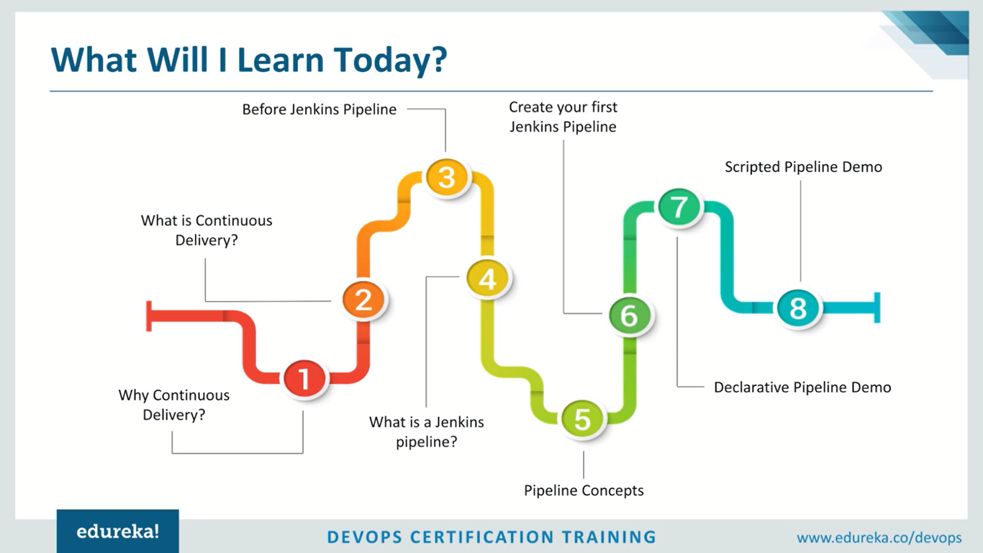

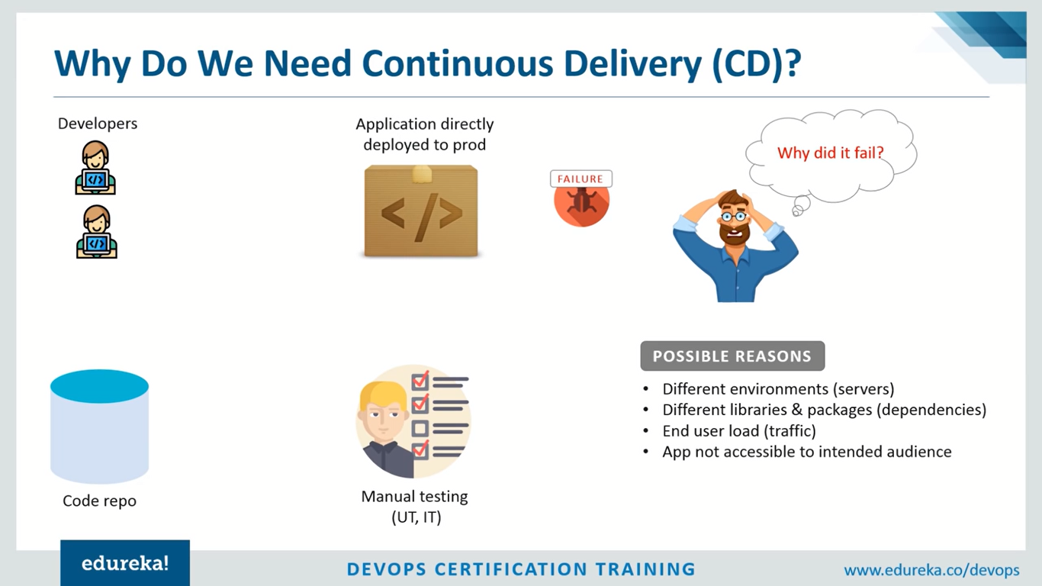

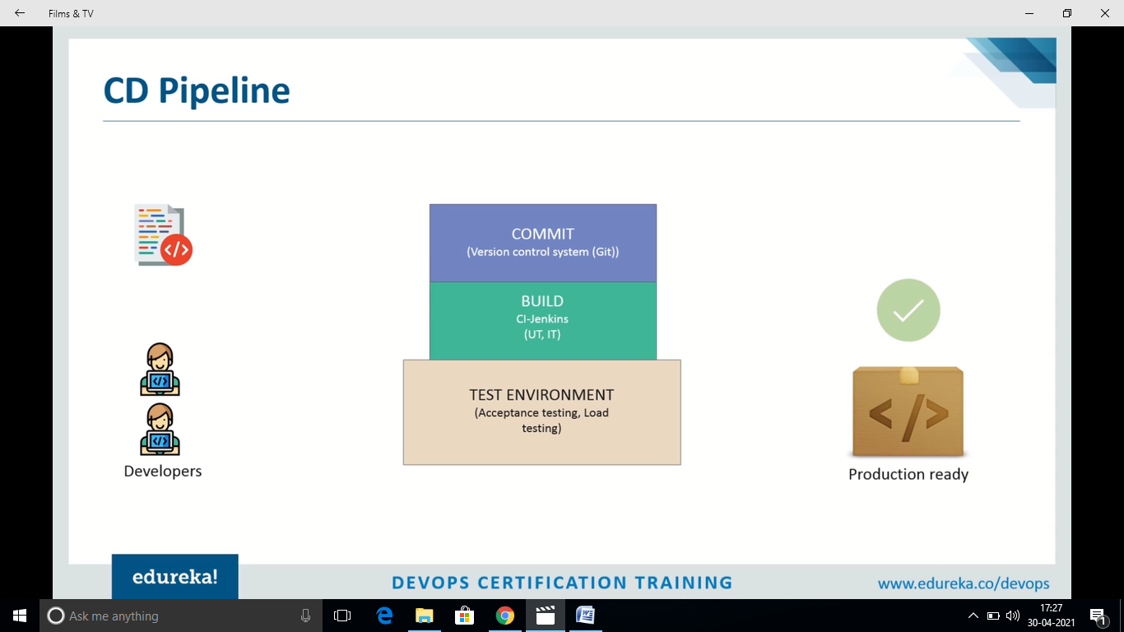

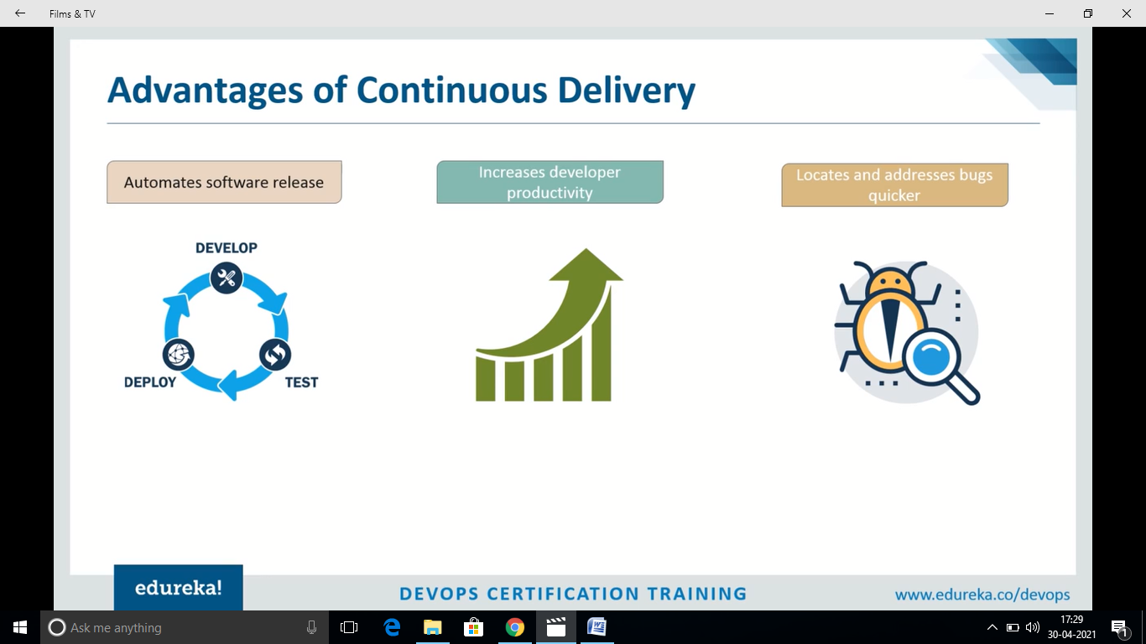

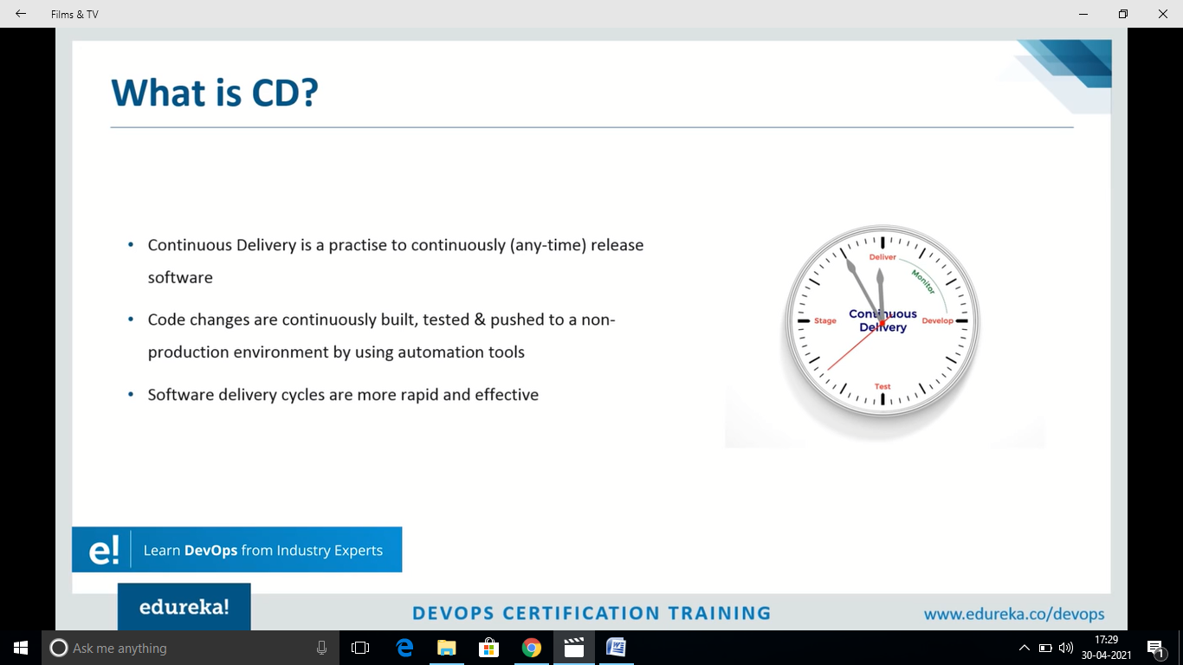

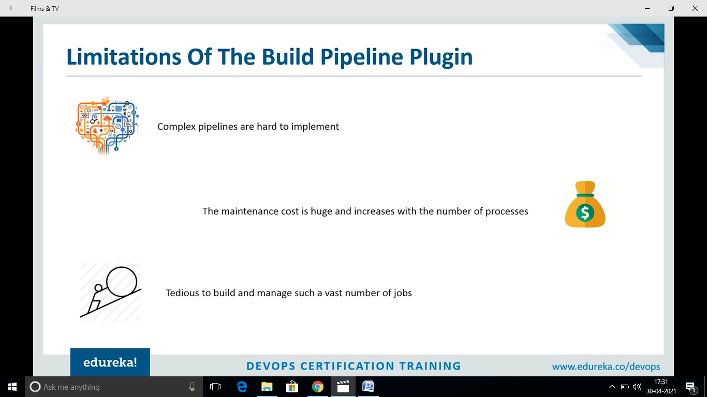

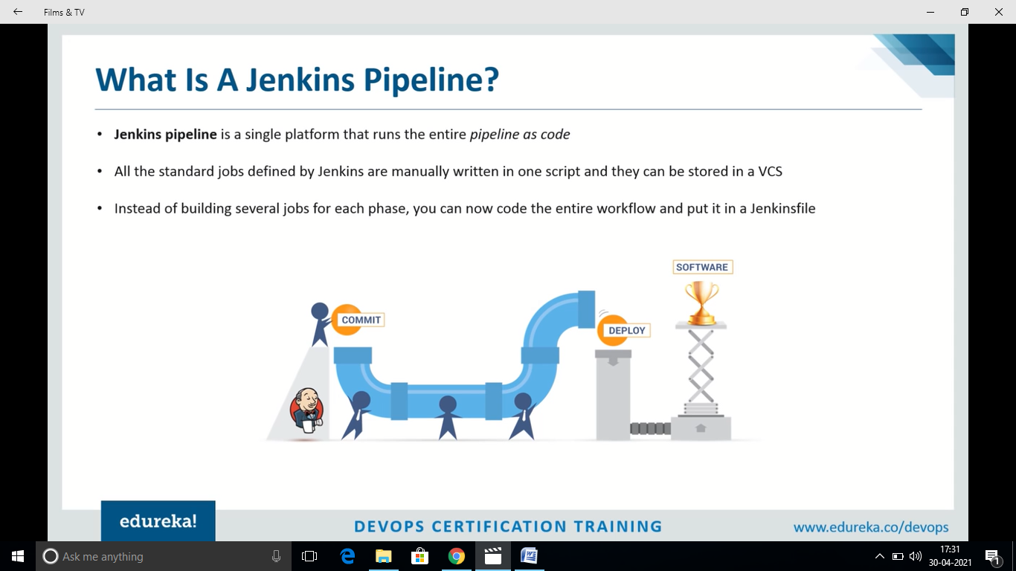

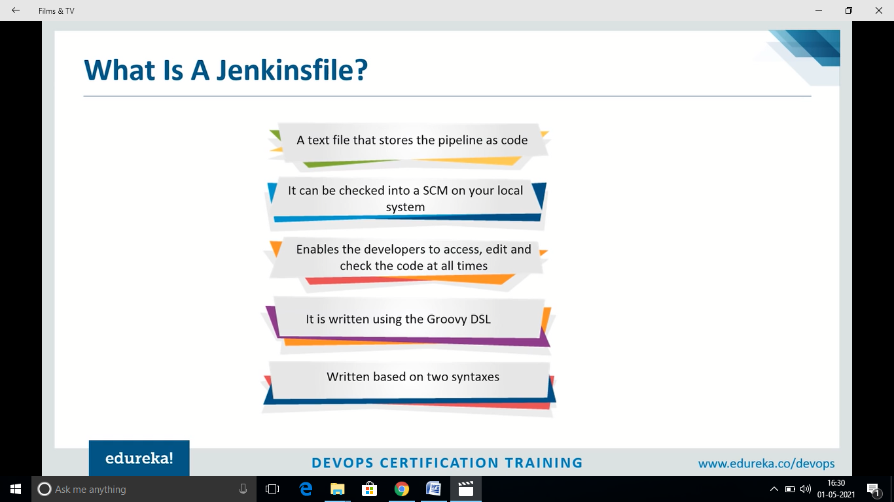

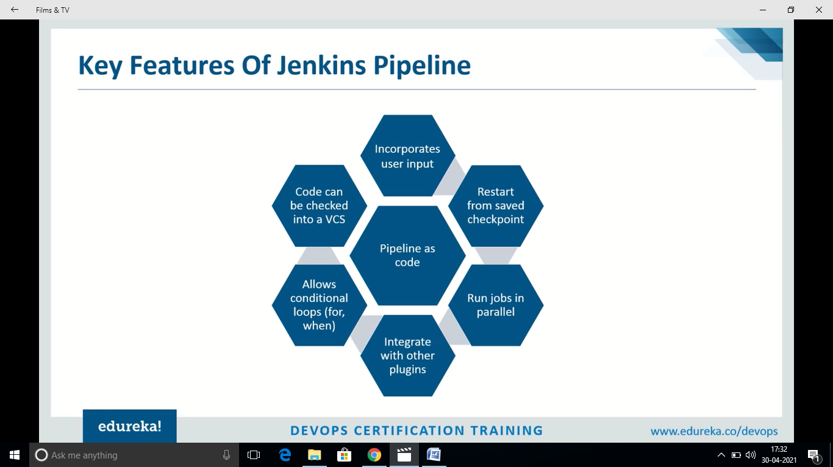

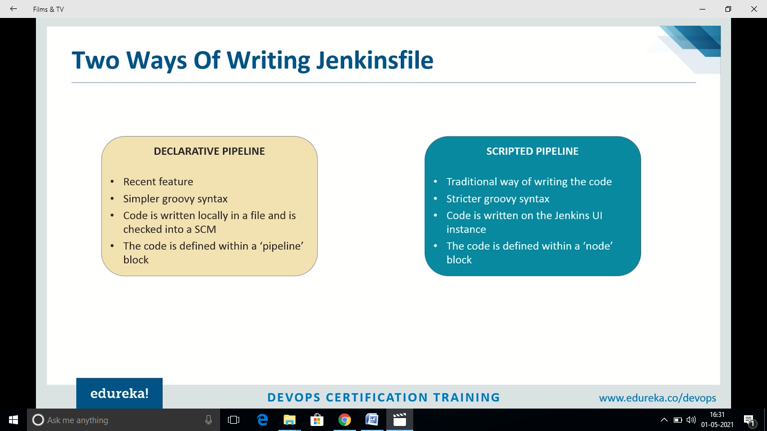

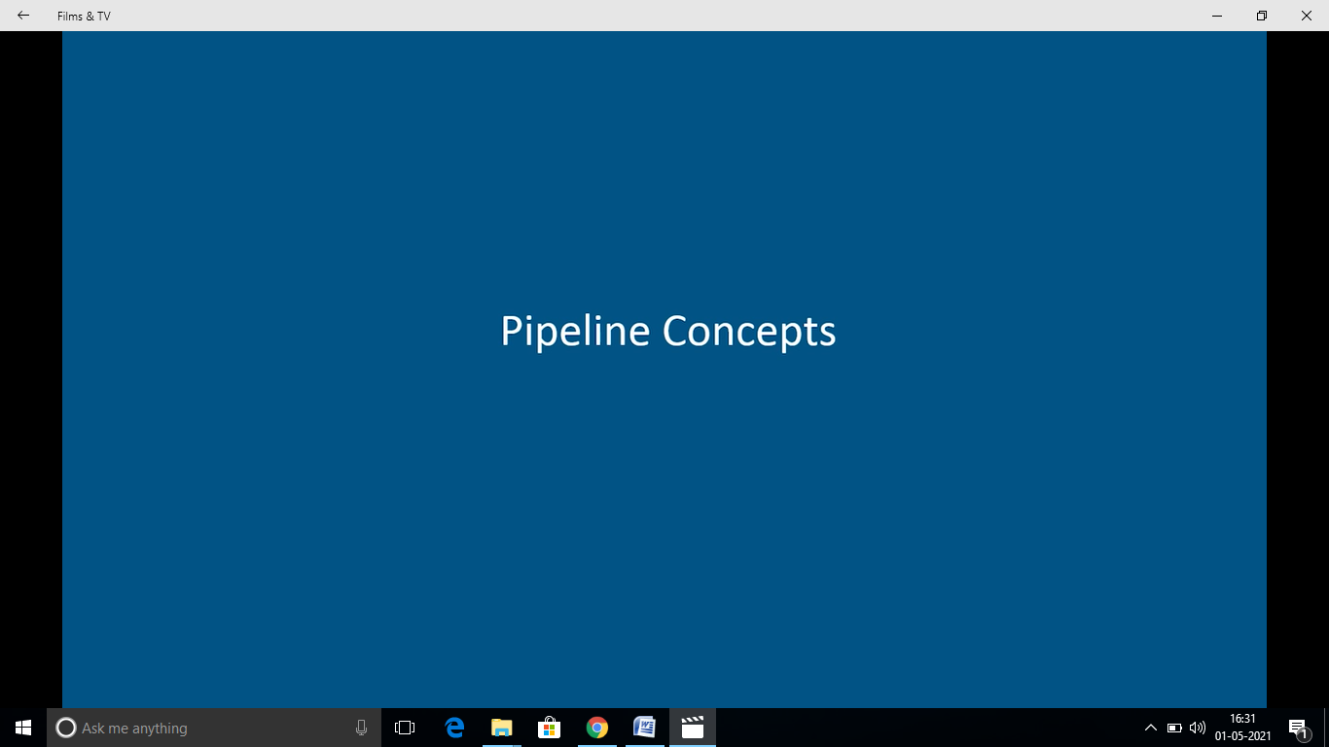

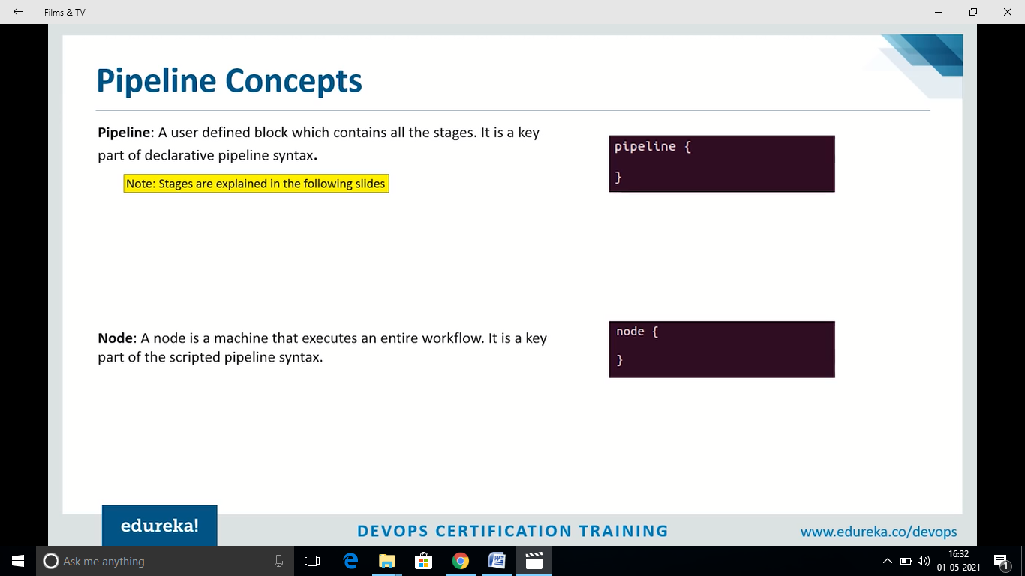

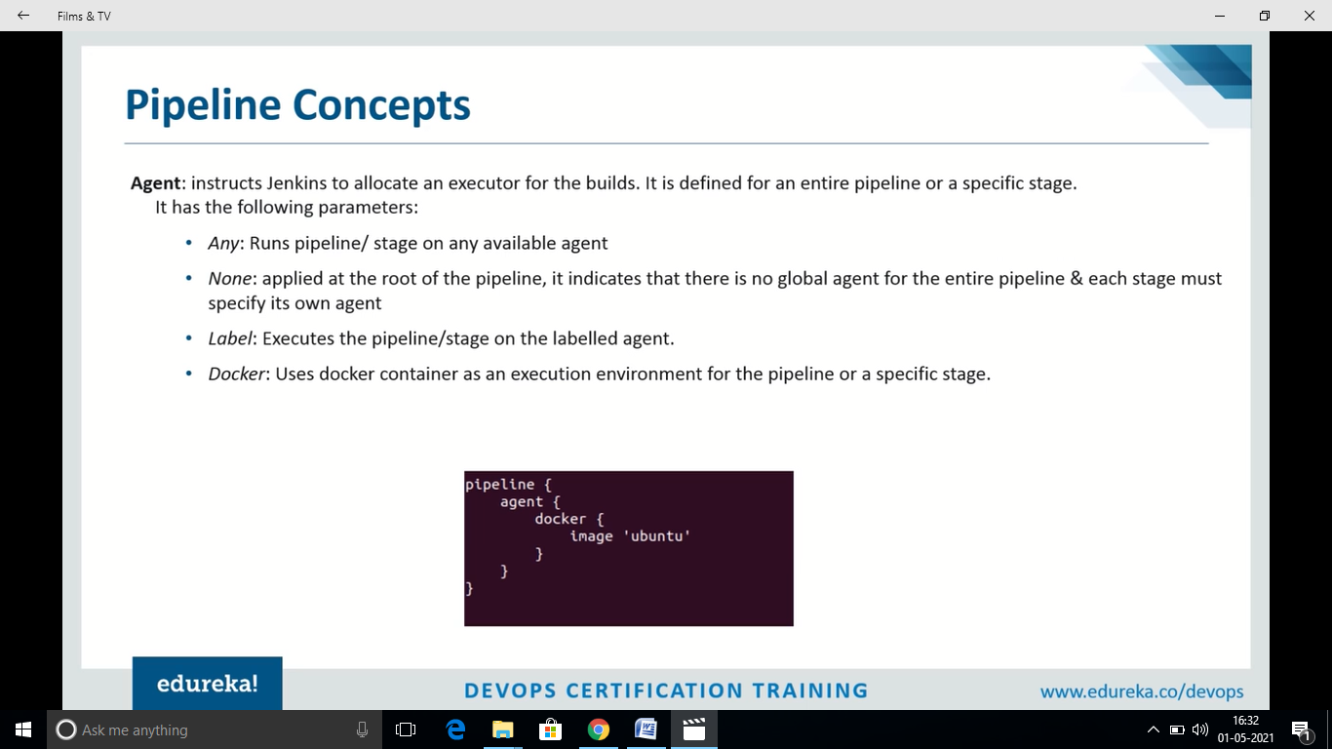

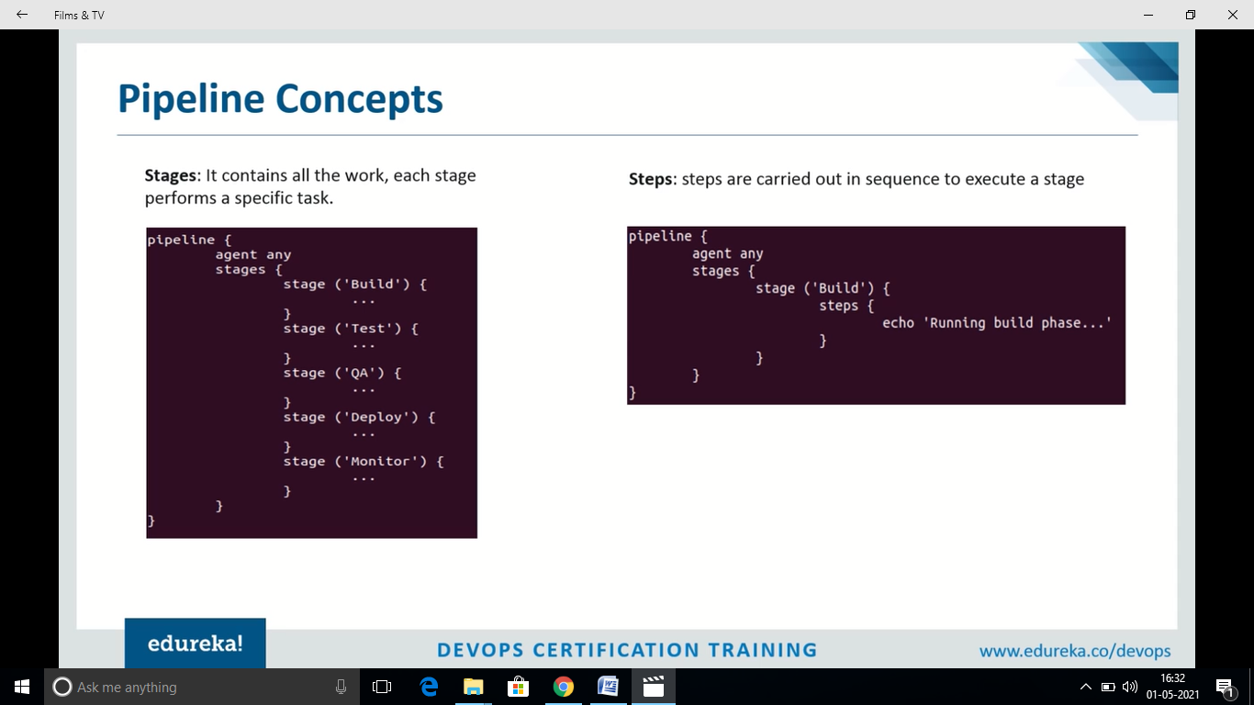

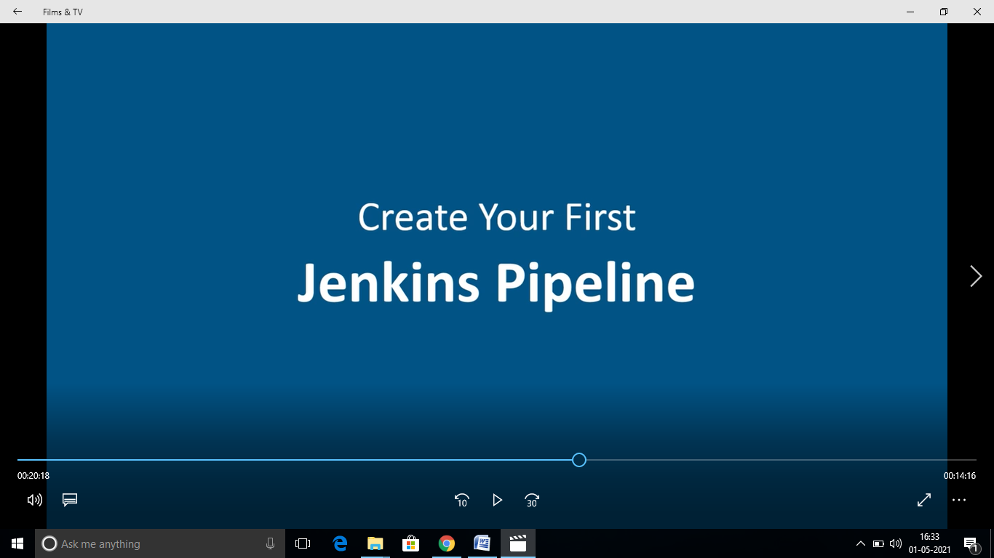

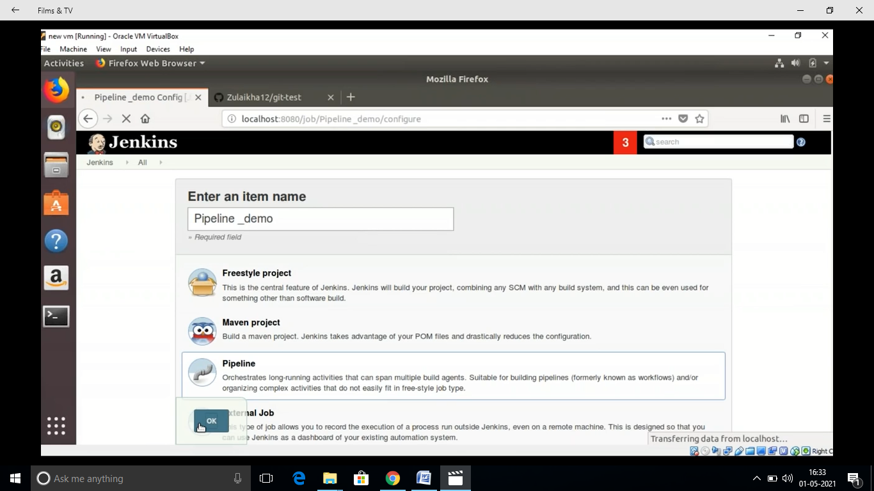

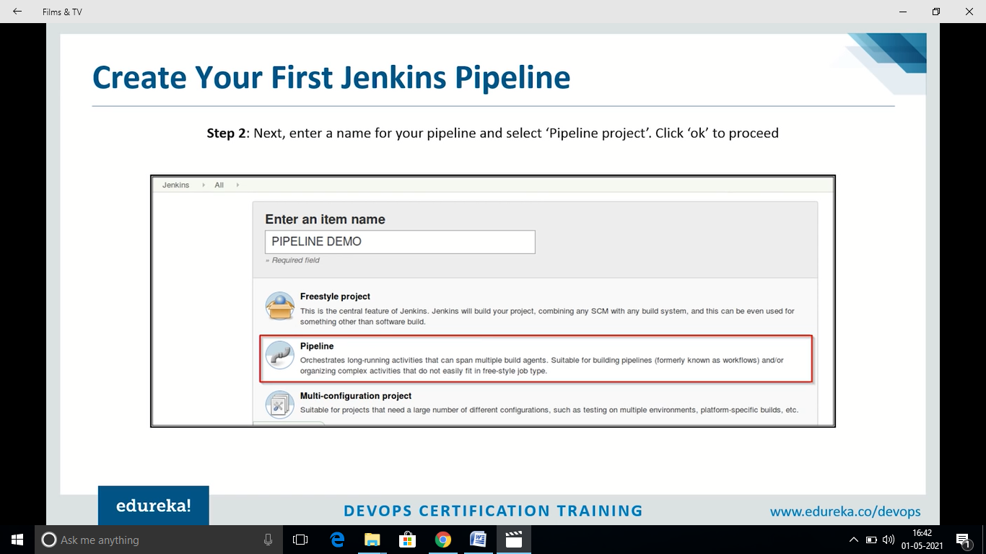

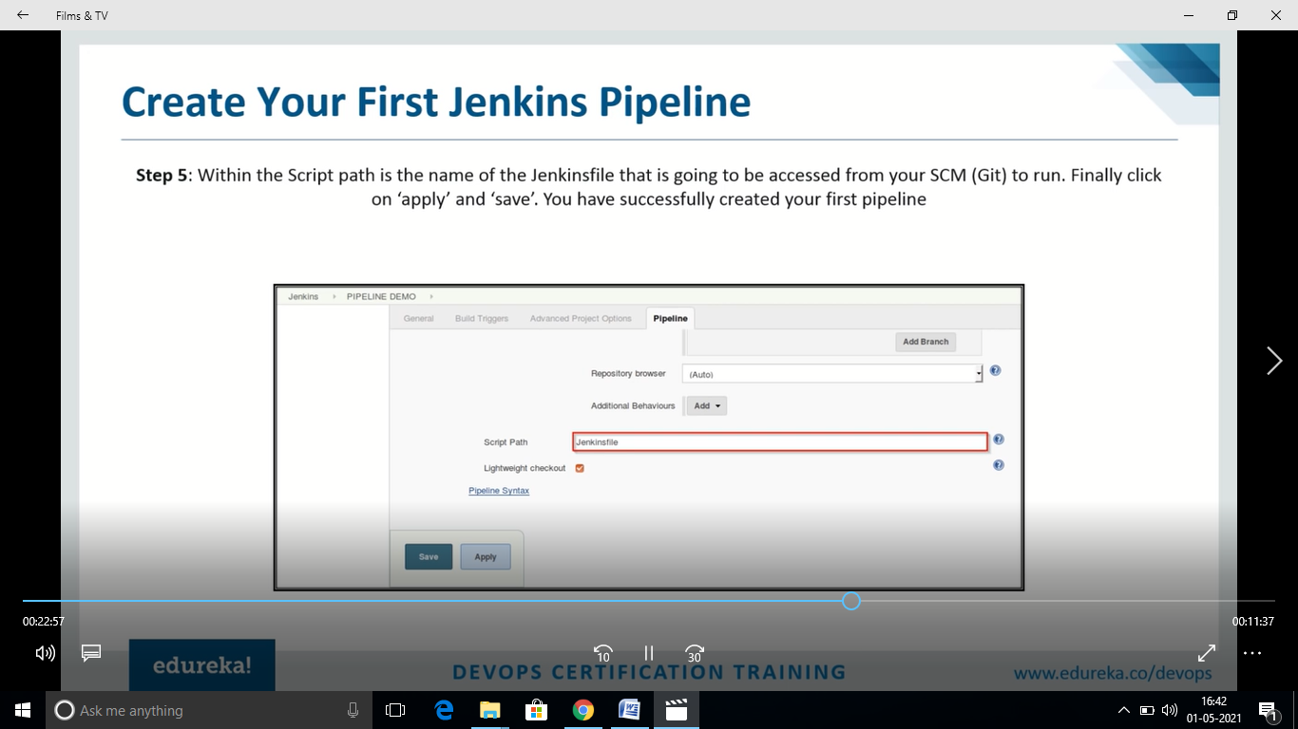

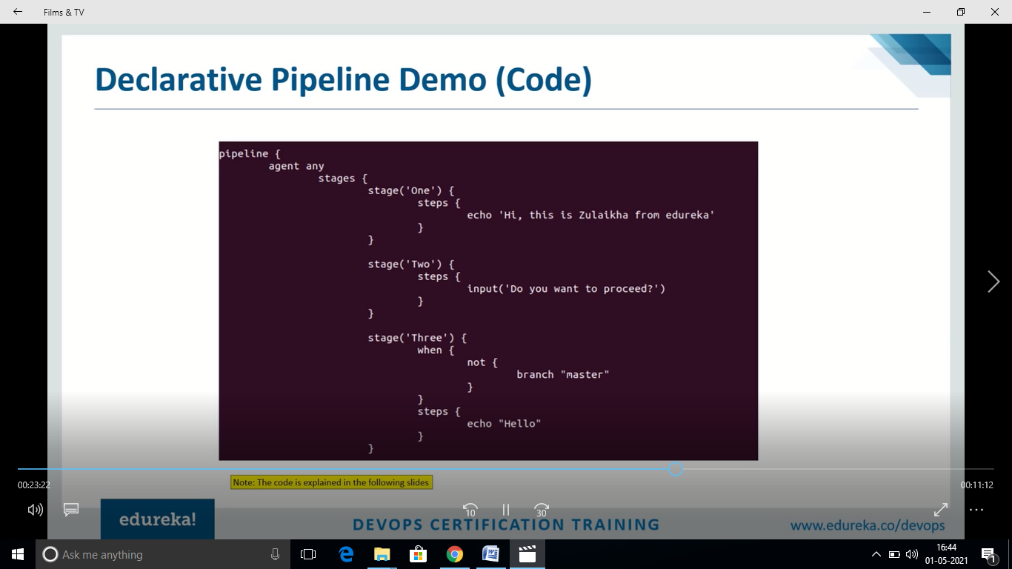

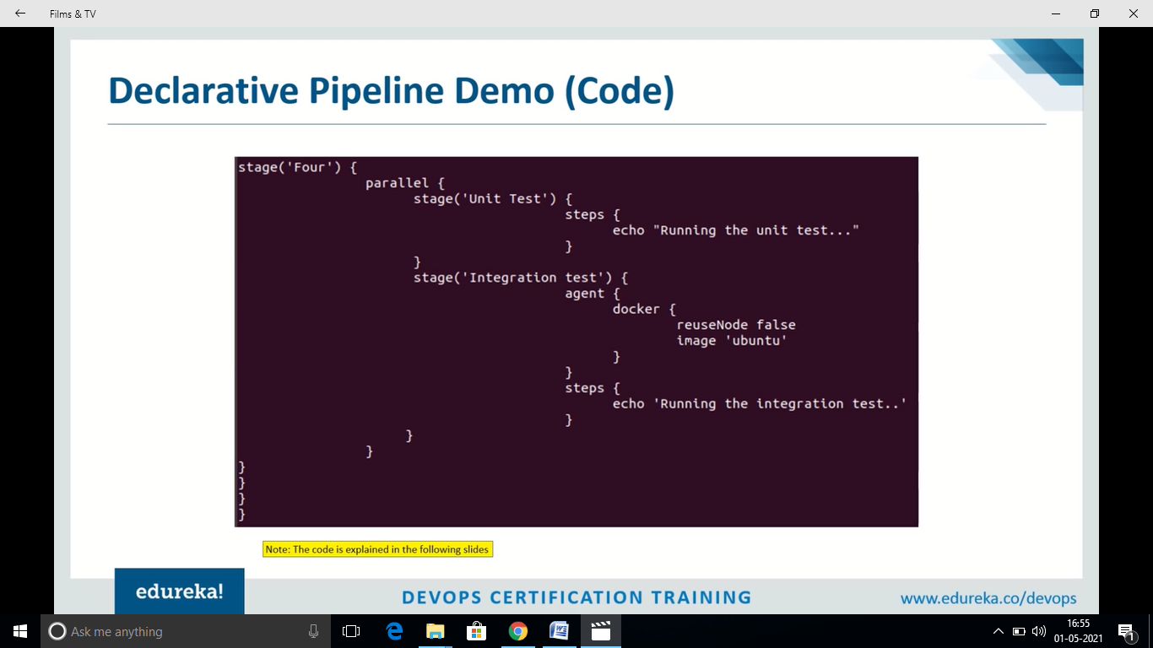

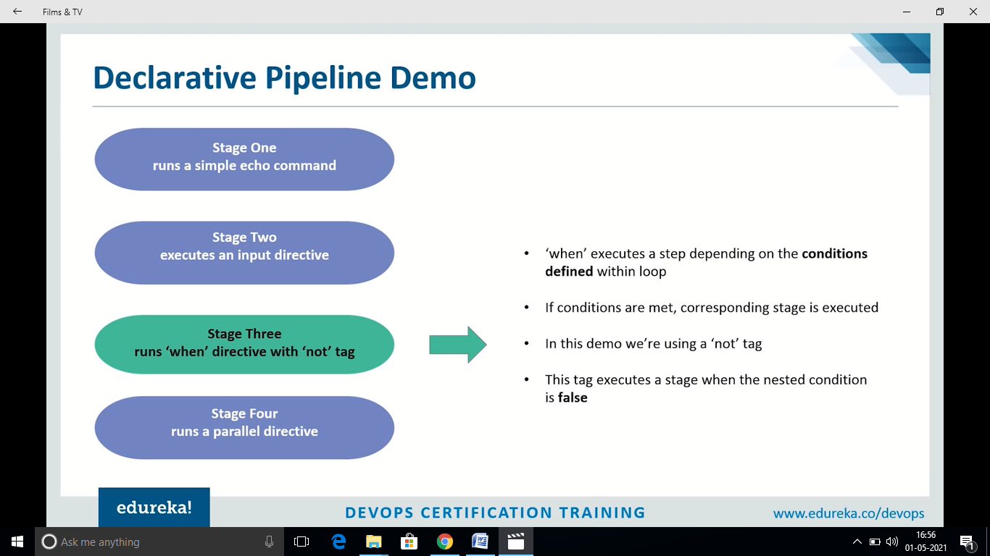

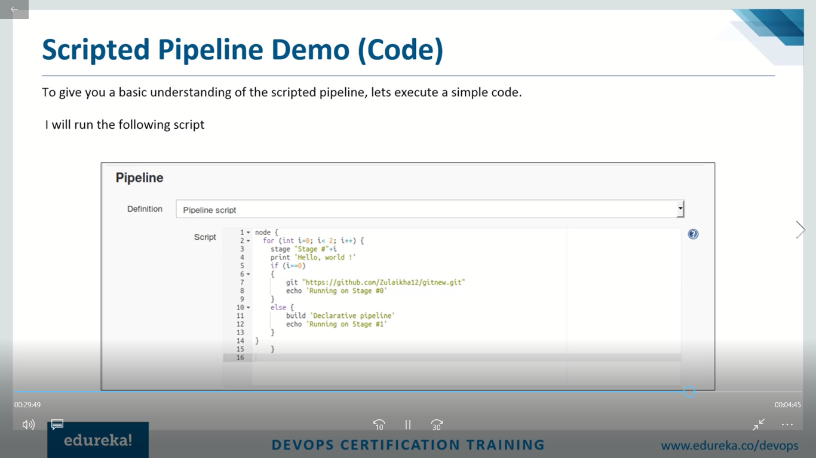

**Create multi branch pipeline with Git**

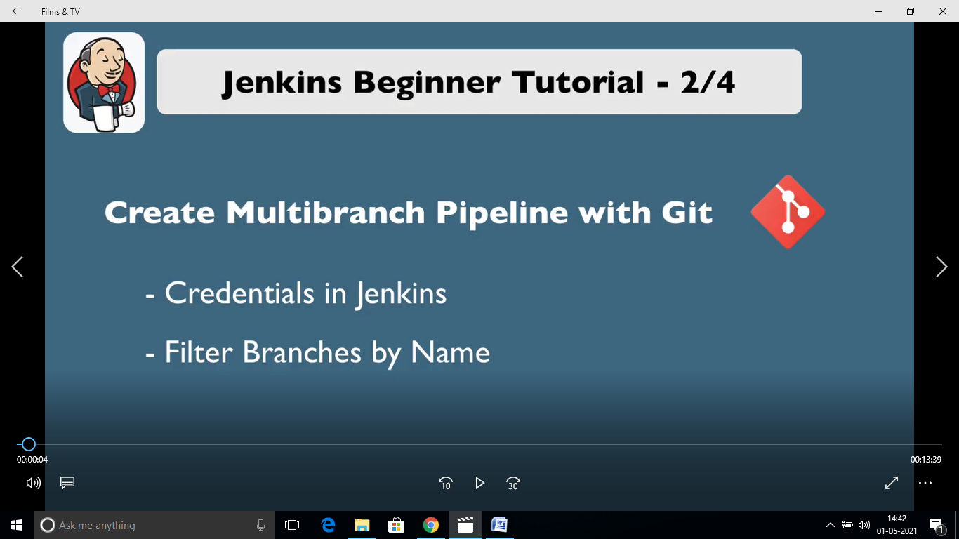

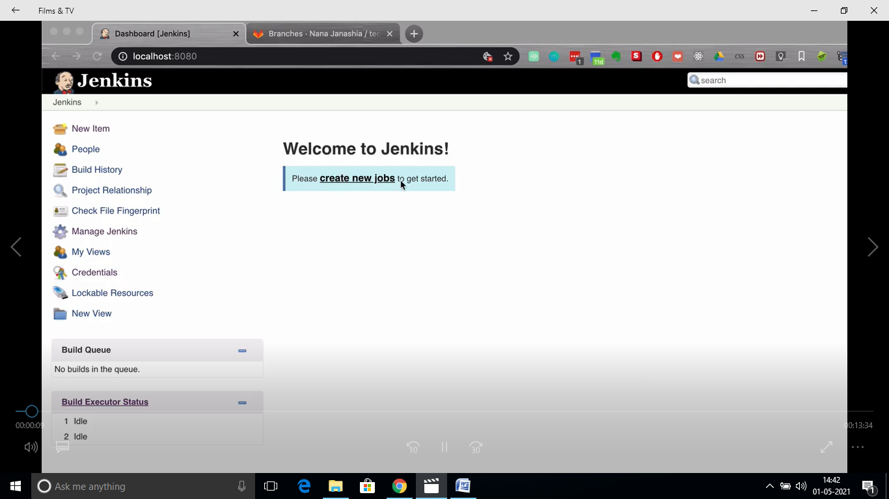

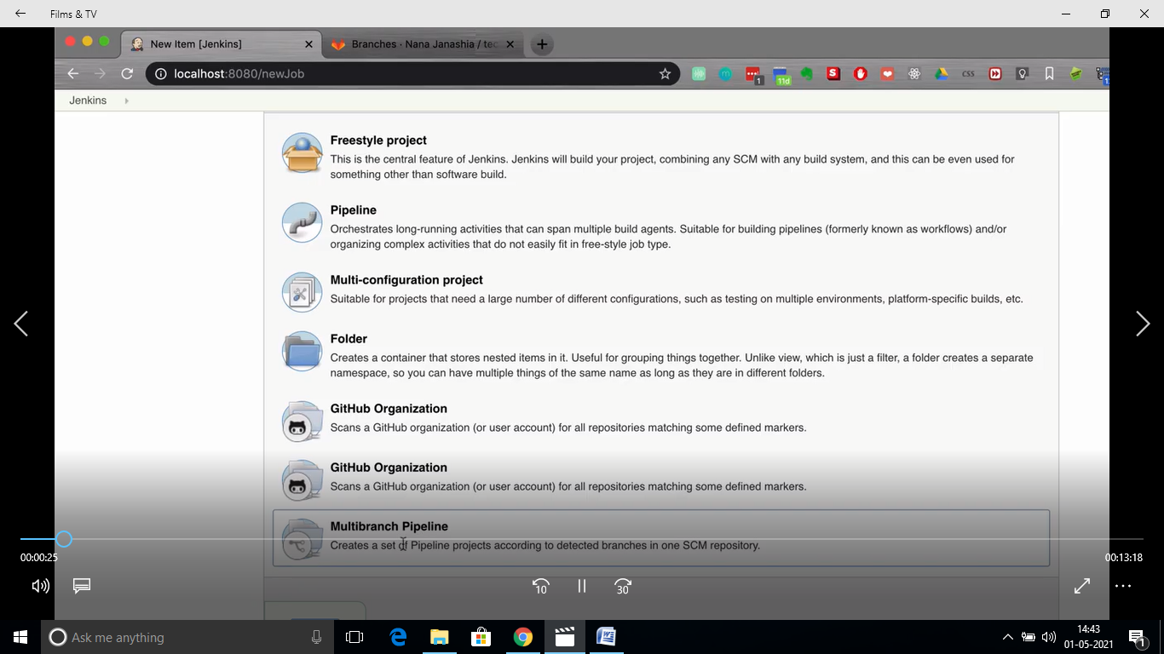

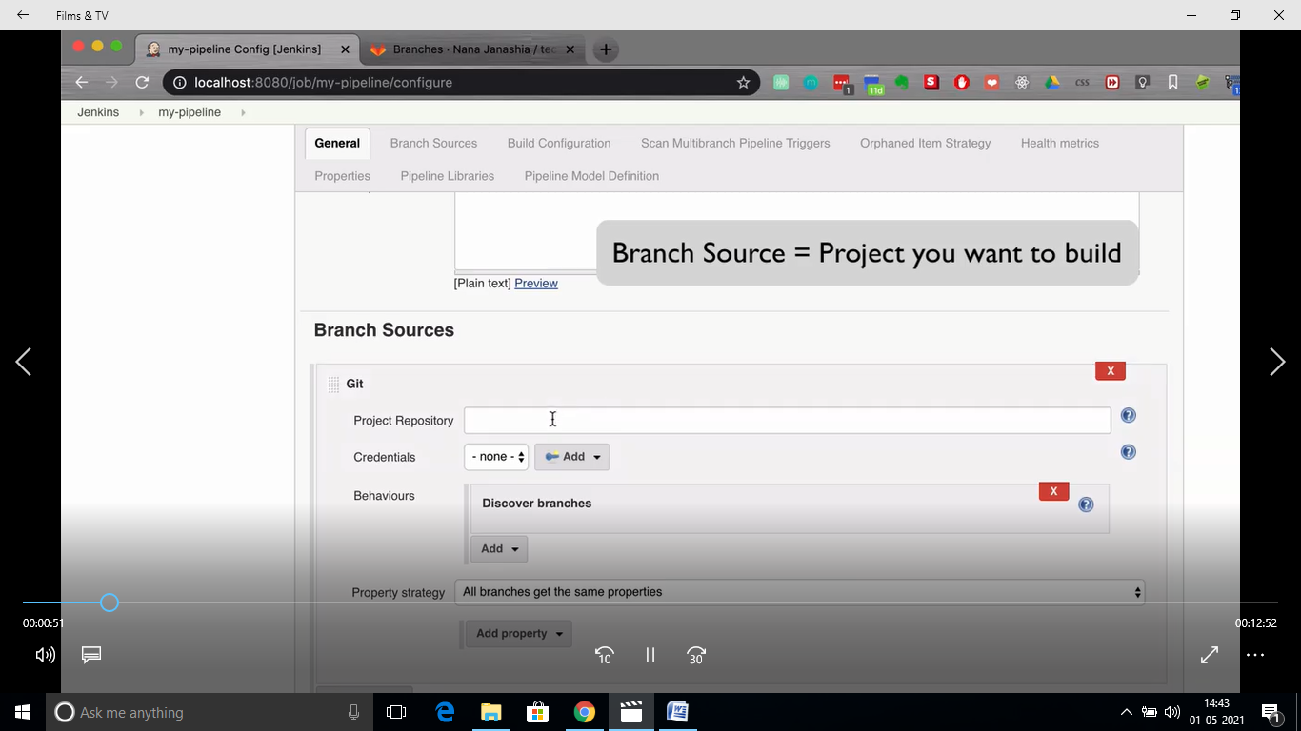

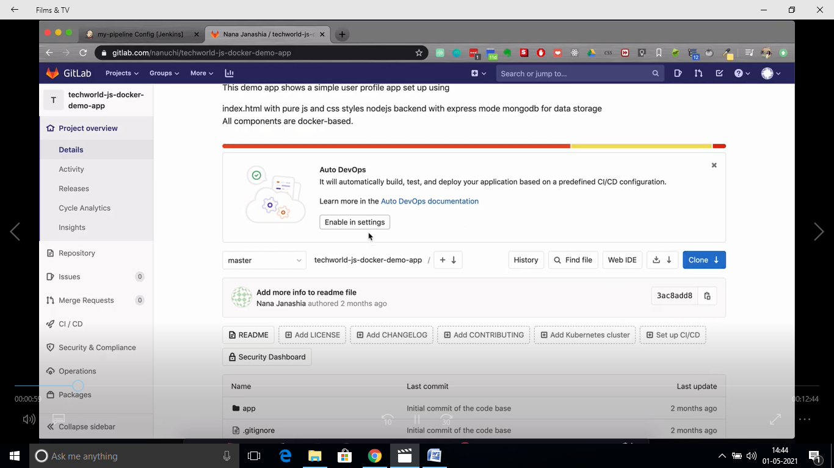

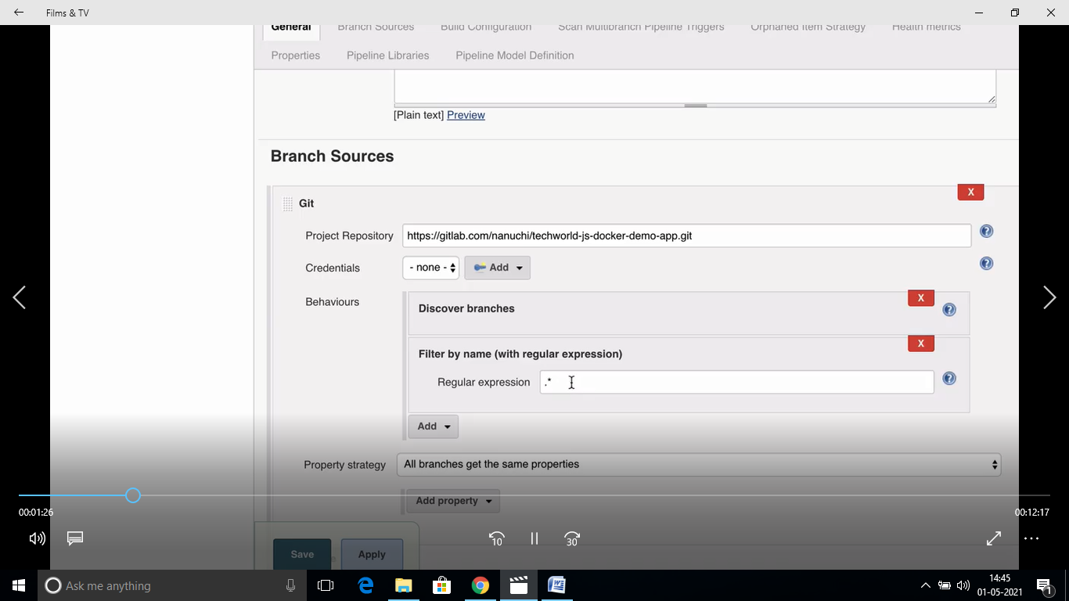

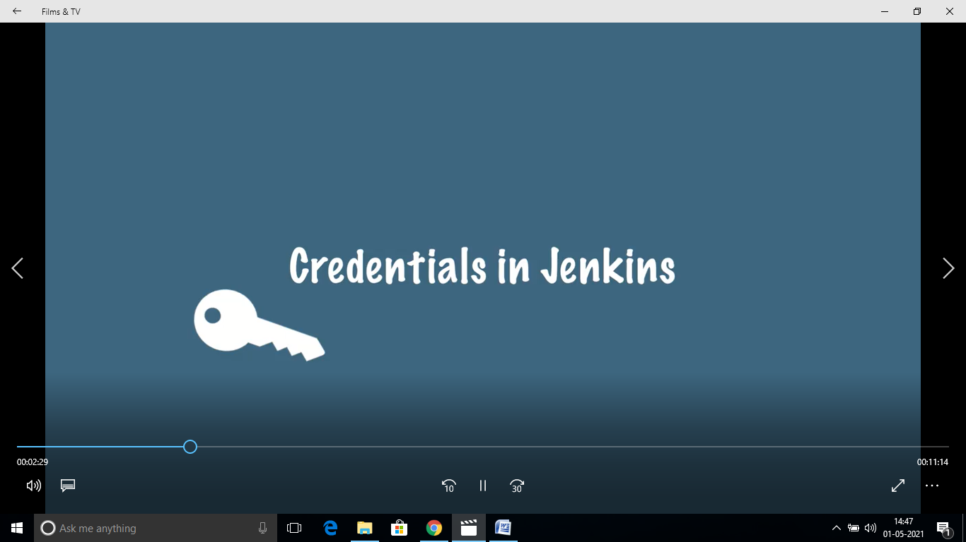

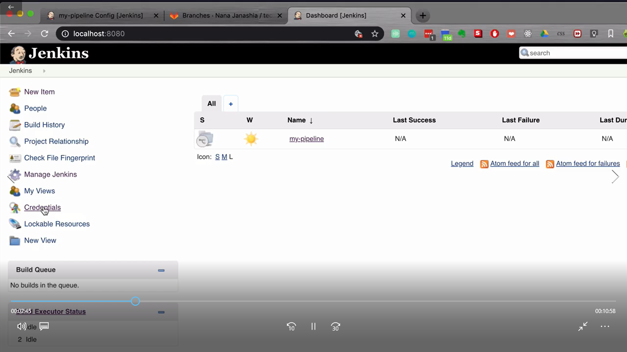

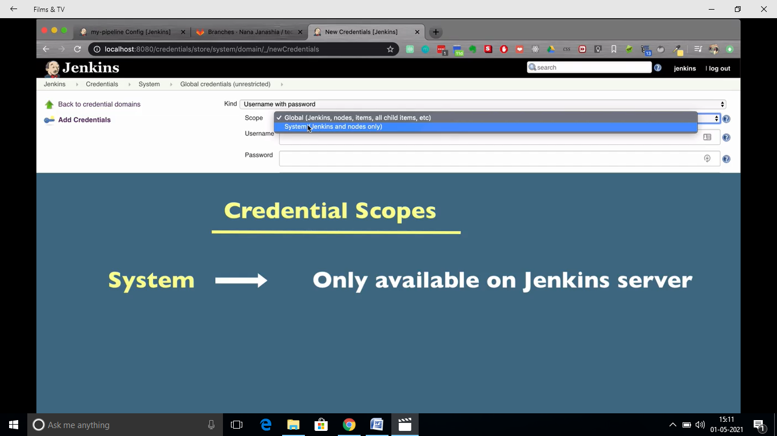

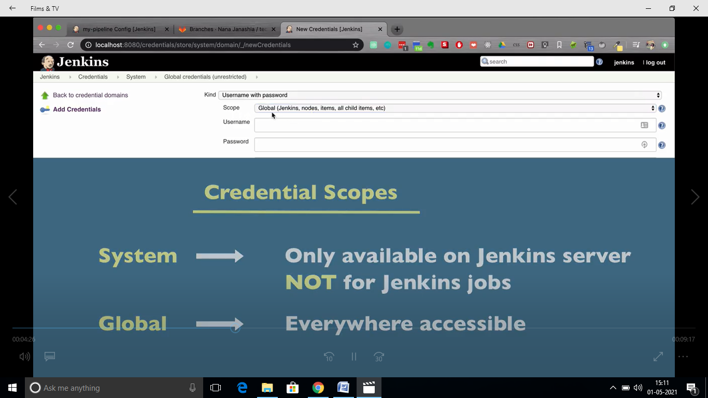

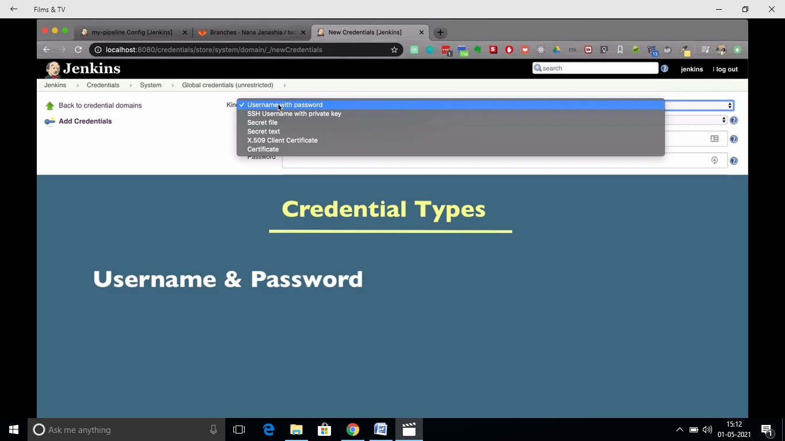

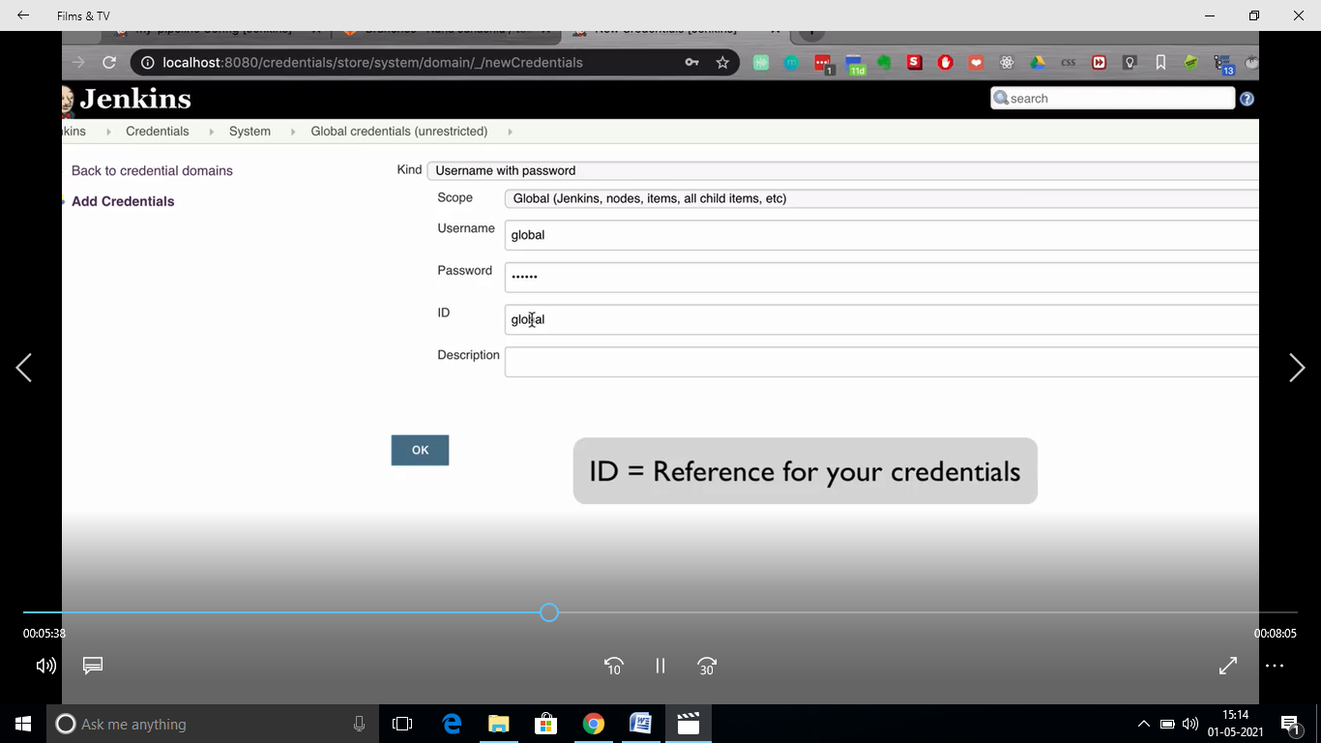

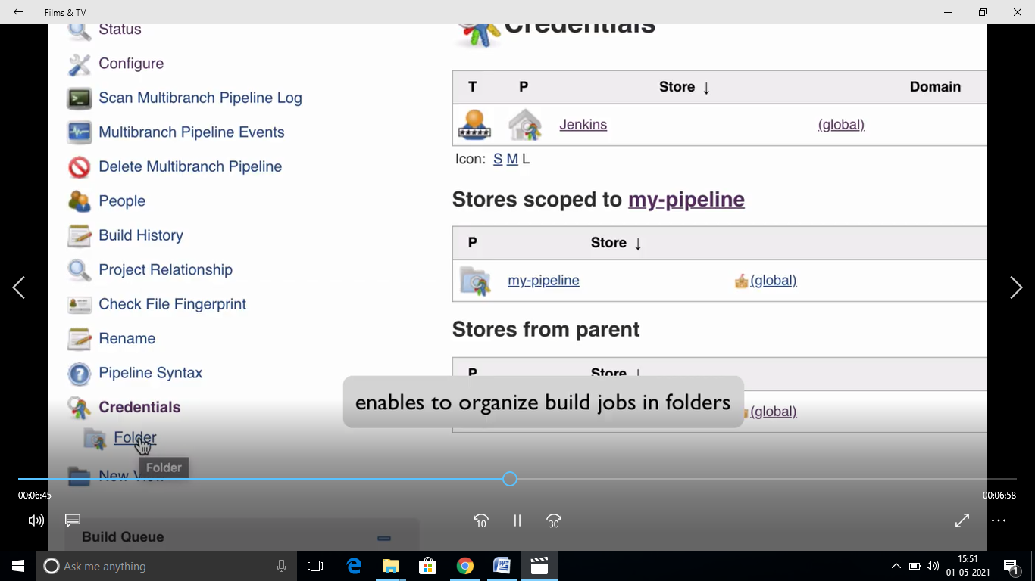

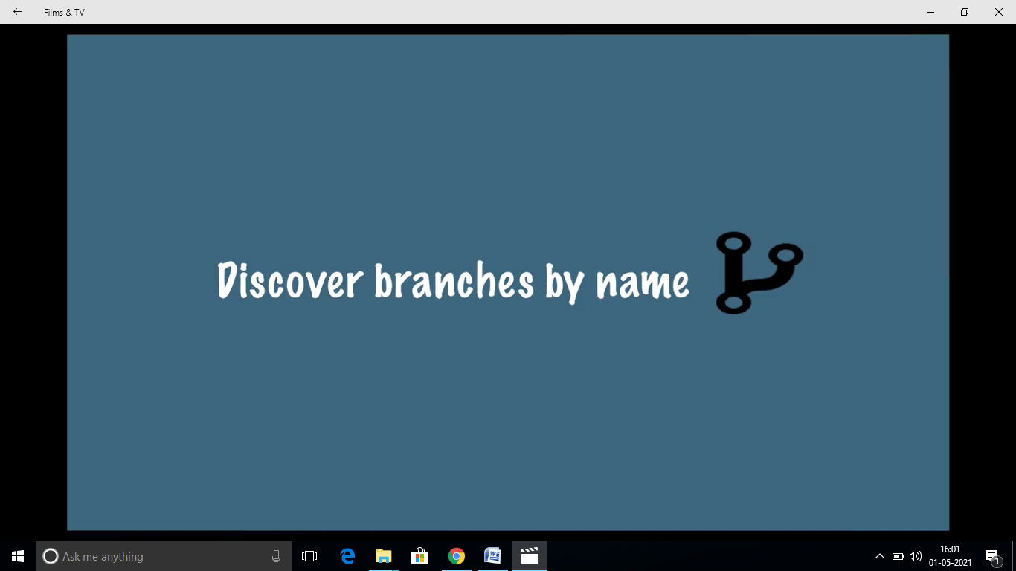

**MASTER-SLAVE CONFIGURATION**

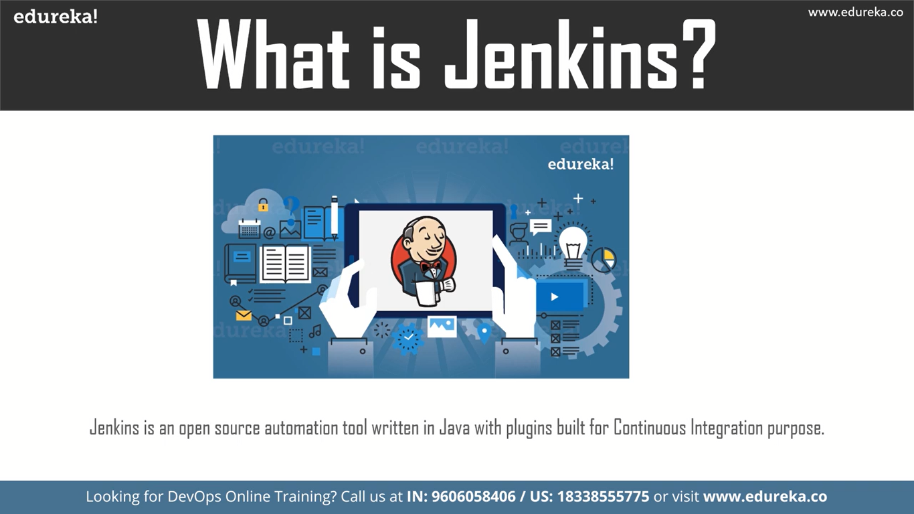

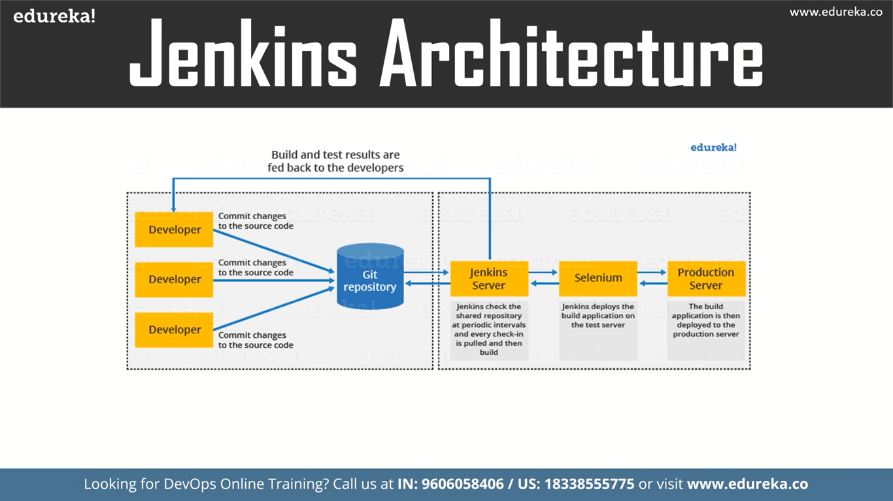

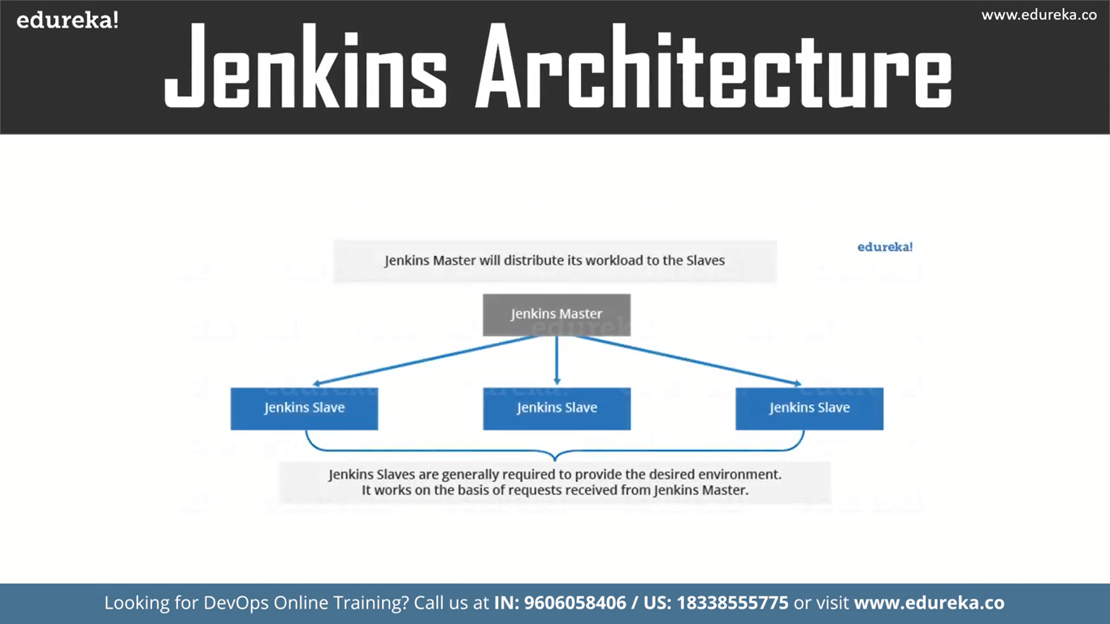

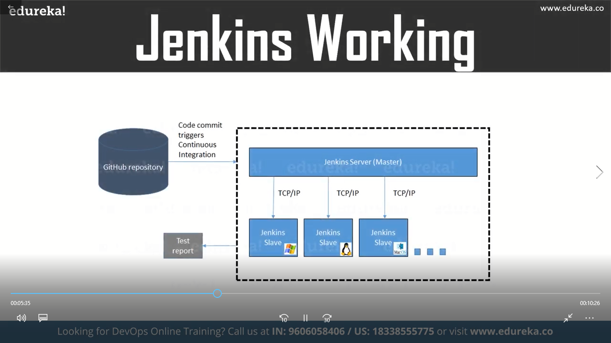

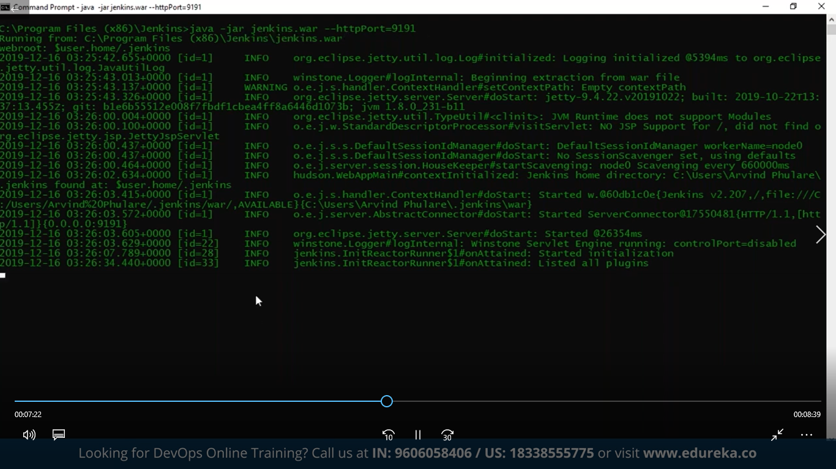

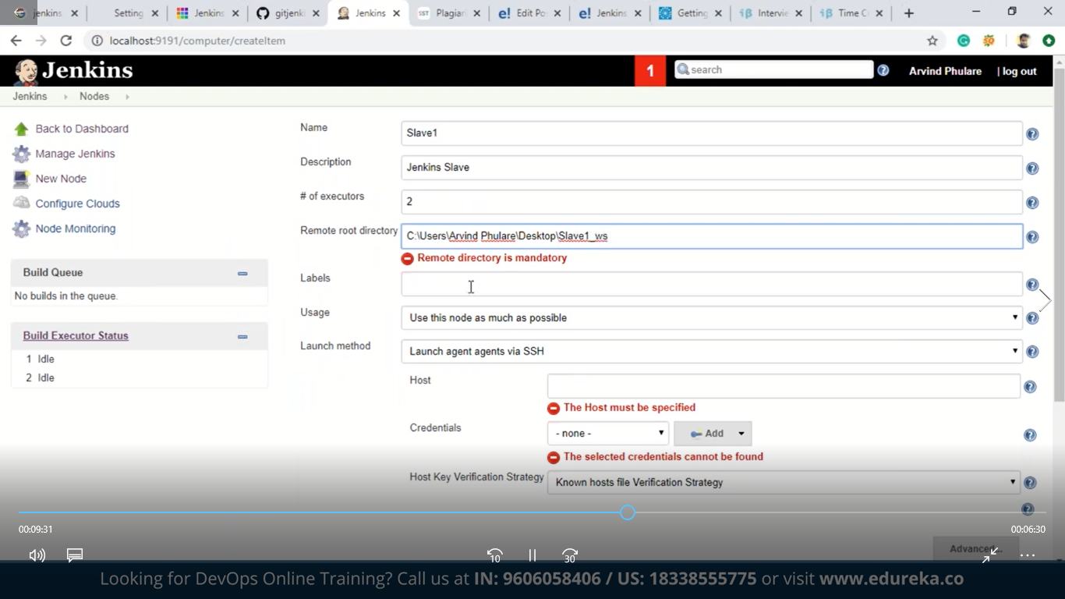

**Jenkins Master and Slave Concept**

A Jenkins master comes with the basic installation of Jenkins, and in this configuration, the master handles all the tasks for your build system.

**You may also enjoy:**[**Getting Started With Jenkins: The Ultimate Guide**](https://dzone.com/articles/getting-started-with-jenkins-the-ultimate-guide)

If you are working on multiple projects you may run multiple jobs on each and every project. Some projects need to run on some particular nodes, and in this process, we need to configure slaves. [Jenkins slaves connect to the Jenkins master](https://dzone.com/articles/asynchronous-master-slave-replication-of-postgresq) using the Java Network Launch Protocol.

**Jenkins Master and Slave Architecture**

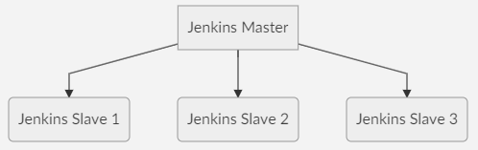

The Jenkins master acts to schedule the jobs and assign slaves and send builds to slaves to execute the jobs.

It will also monitor the slave state (offline or online) and getting back the build result responses from slaves and the display build results on the console output. The workload of building jobs is delegated to multiple **slaves**.

**Steps to Configure Jenkins Master and Slave Nodes**

1. Click on **Manage Jenkins** in the left corner on the Jenkins dashboard.
2. Click on **Manage Nodes**.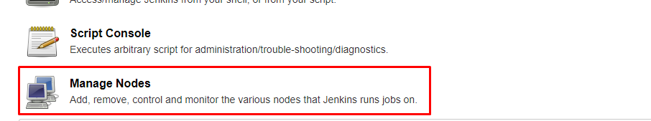
3. Select **New Node**andenter the name of the node in the Node Name field.
4. Select **Permanent Agent** and click the **OK**button. Initially, you will get only one option, "Permanent Agent." Once you have one or more slaves you will get the "Copy Existing Node" option.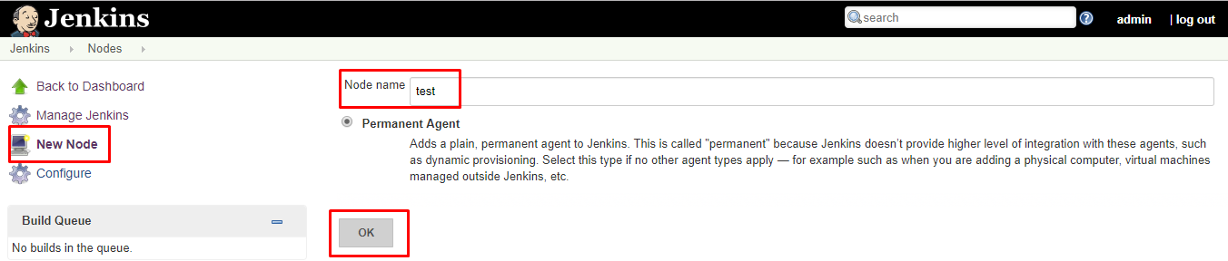
5. Enter the required information.

Some required fields include:

1

Name: Name of the Slave. e.g: Test

2

​

3

Description: Description for this slave (optional). e.g: testing slave

4

​

5

# of Executors: Maximum number of Parallel builds Jenkins master perform on this slave. e.g: #2

6

​

7

Remote root directory: A slave needs to have a directory dedicated to Jenkins. Specify the path to this directory on the agent. e.g: /home/

8

​

9

Usage: Controls how Jenkins schedules builds on this node. e.g: Only build jobs with label expressions matching this node.

10

​

11

Launch method: Controls how Jenkins starts this agent. e.g: Launch agent agents via SSH

6. Enter the Hostname in the **Host** field.

7. Select the **Add** button to add credentials. and click **Jenkins**.

8. Enter **Username, Password, ID, and Description**.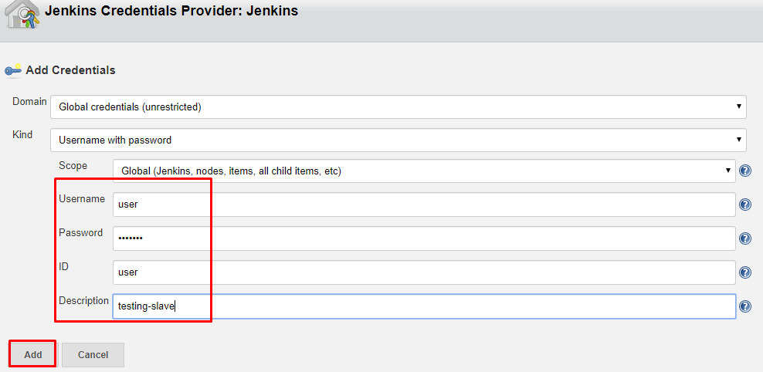

9. Select the dropdown menu to add credentials in the **Credentials** field.

10. Select the next dropdown to add the Host Key Verification Strategy under **Non verifying Verification Strategy**.

11. Select **Keep this agent online as much as possible**in the Availability field.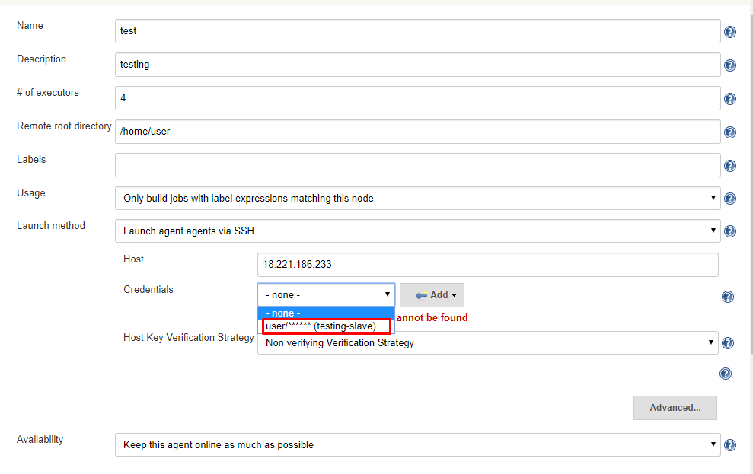

12. Click the **Save**button.

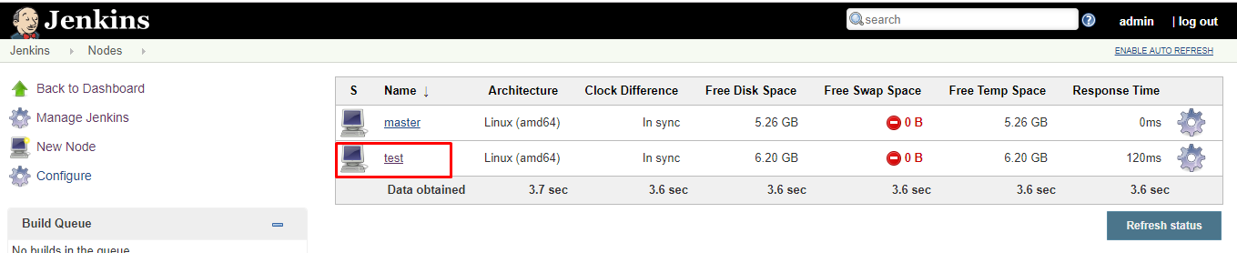

**Creating a Freestyle Project and Running on The Slave Machine**

1. Click on **Save** and it will redirect to job's view page
2. On the left pane, click the **Build Now** button to execute your Pipeline.
3. We can verify the history of the executed build under the **Build History** by clicking the build number.
4. Click on the build number and select **Console Output**. Here you can see the executed job in the remote host and output.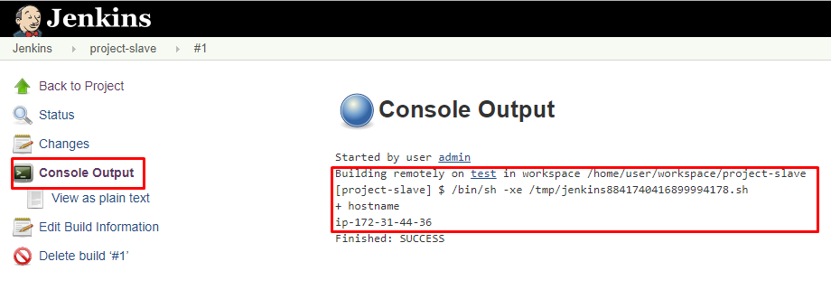

**Creating a Pipeline and Running on The Slave Machine**

1. Click **New Item** in the top left corner on the dashboard.
2. Enter the name of your project in the **Enter an item name**field, and select the **Pipeline** project, and click **OK**button.
3. Enter **Description** (optional).
4. Go to the **Pipeline** section, make sure the **Definition** field has the **Pipeline script** option selected.
5. Copy and paste the following declarative Pipeline **script** into a script field.

1

node('test'){

2

stage('stage1') {

3

sh '''echo stage1 steps'''

4

}

5

stage('stage2') {

6

sh '''echo stage2 steps'''

7

}

8

stage('stage3') {

9

sh '''echo stage3 steps'''

10

}

11

}

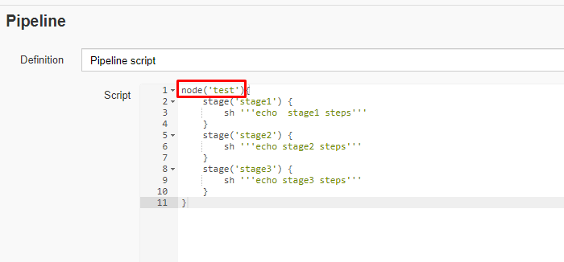

6. Click on **Save**, it will redirect to the Pipeline view page.

7. On the left pane, click the **Build Now** button to execute your Pipeline.

8. After Pipeline execution is completed, the Pipeline view will be as shown below.

9. We can verify the history of executed build under the **Build History** by clicking the build number.

10. Click on build number and select **Console Output**. Here you can see that the pipeline ran on a slave machine.

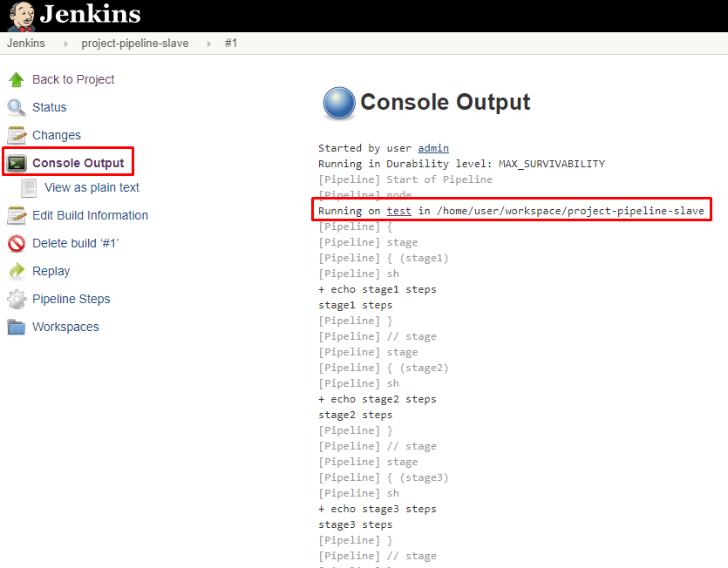

In **software** development, a **build** is the process of converting source code files into standalone **software** artifact(s) that can be run on a computer.

**JENKINS FILE WITH –NANA**

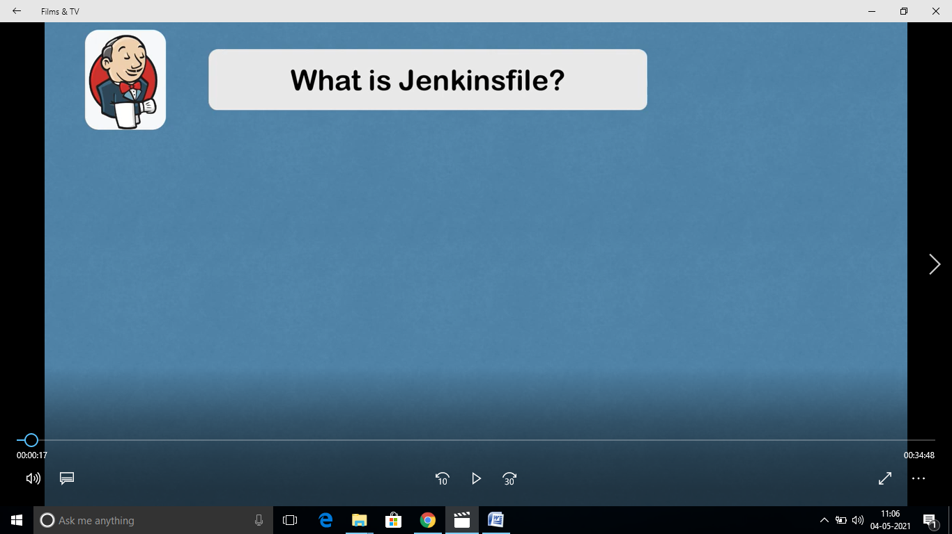

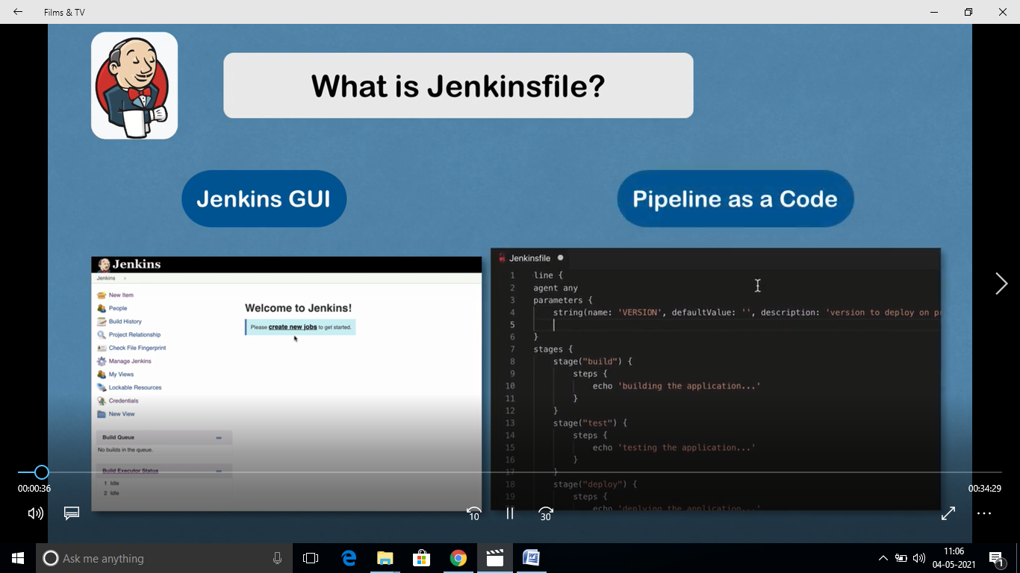

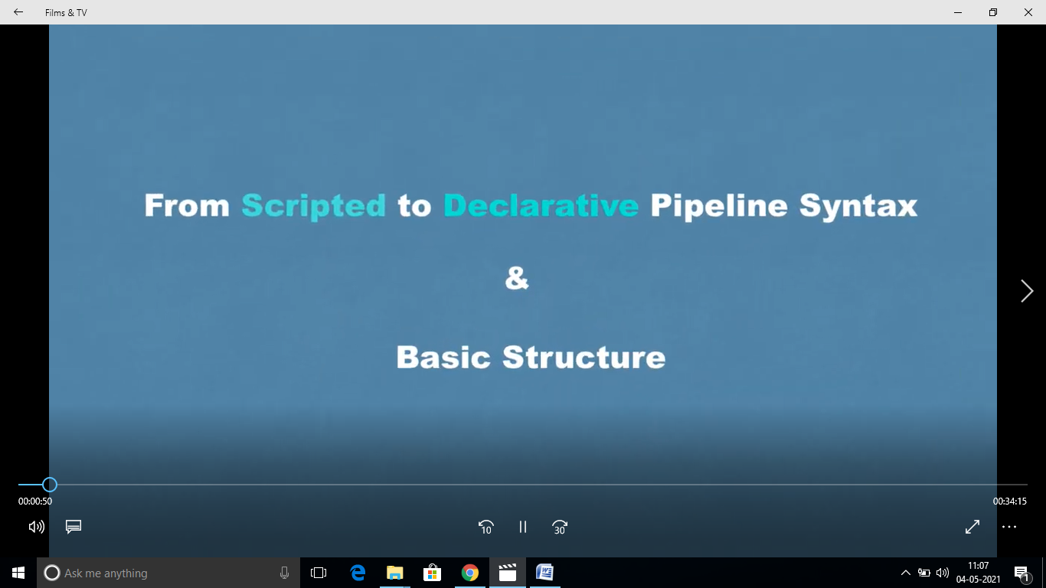

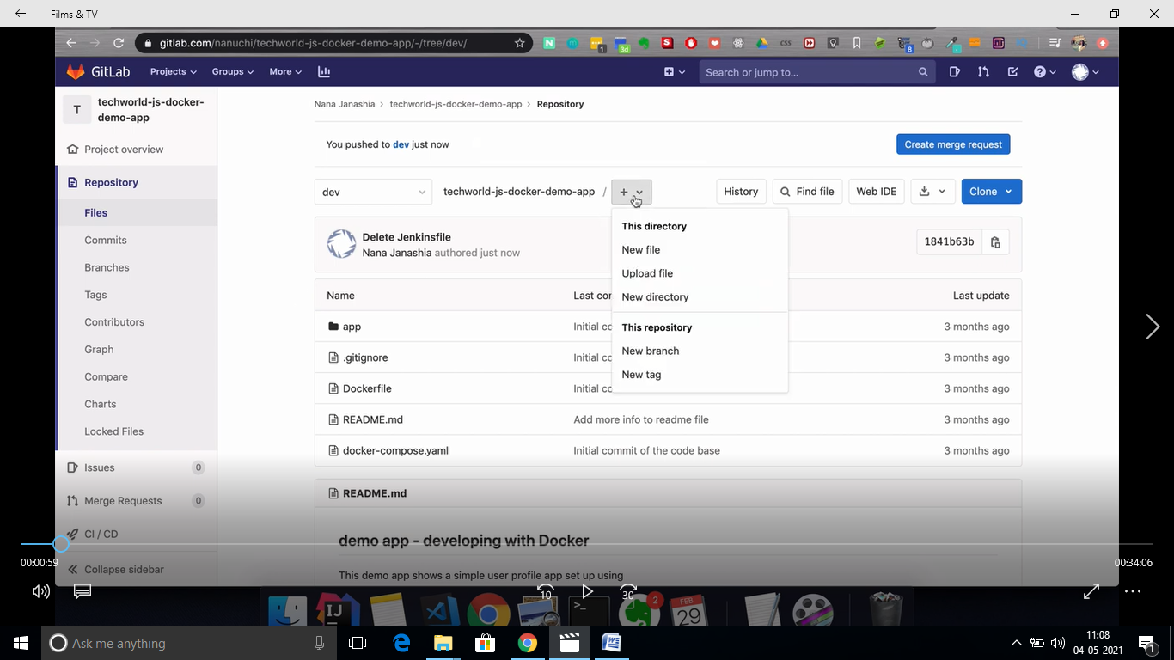

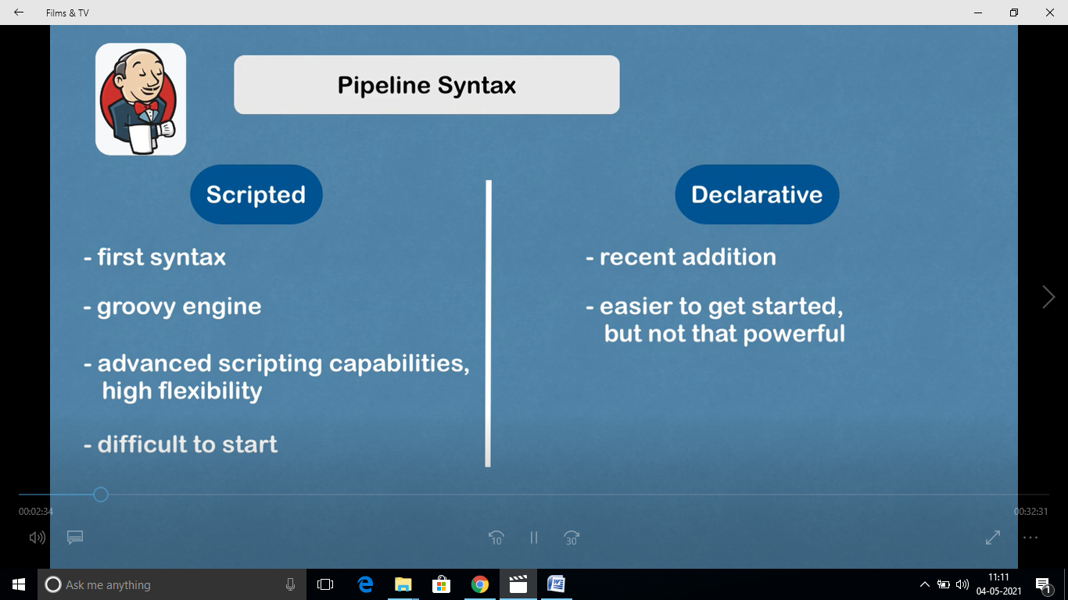

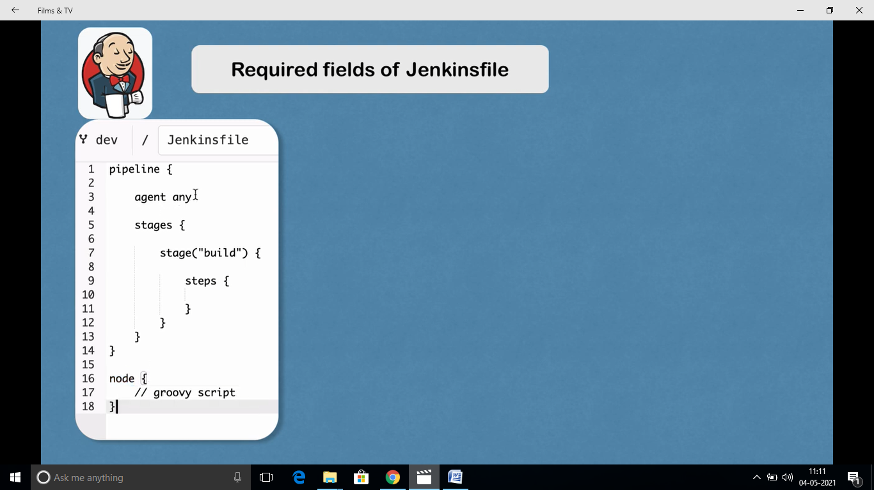

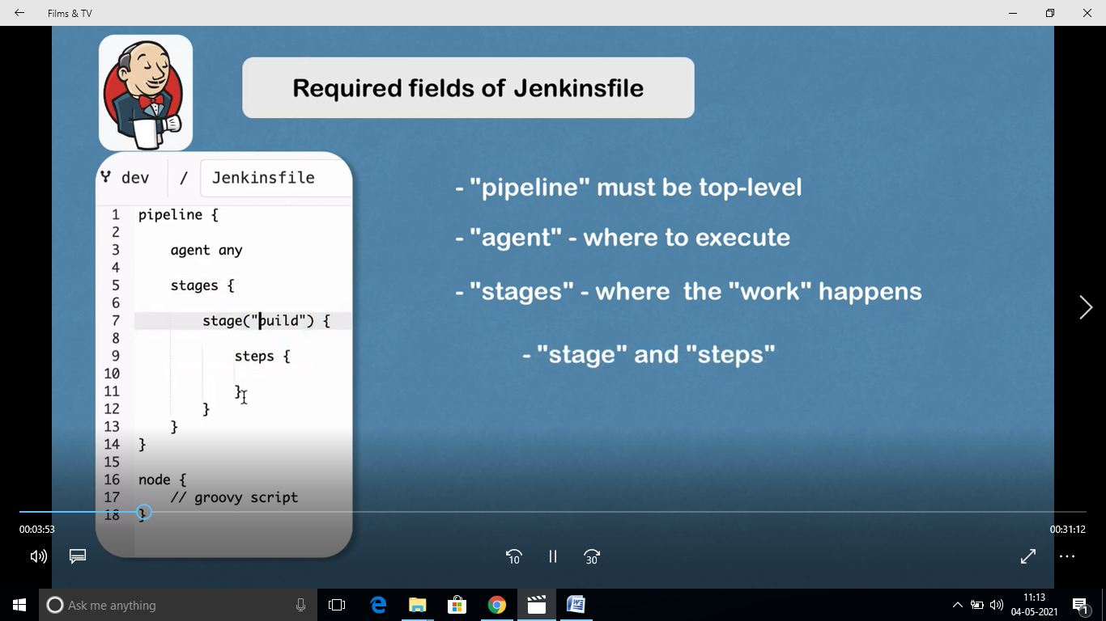

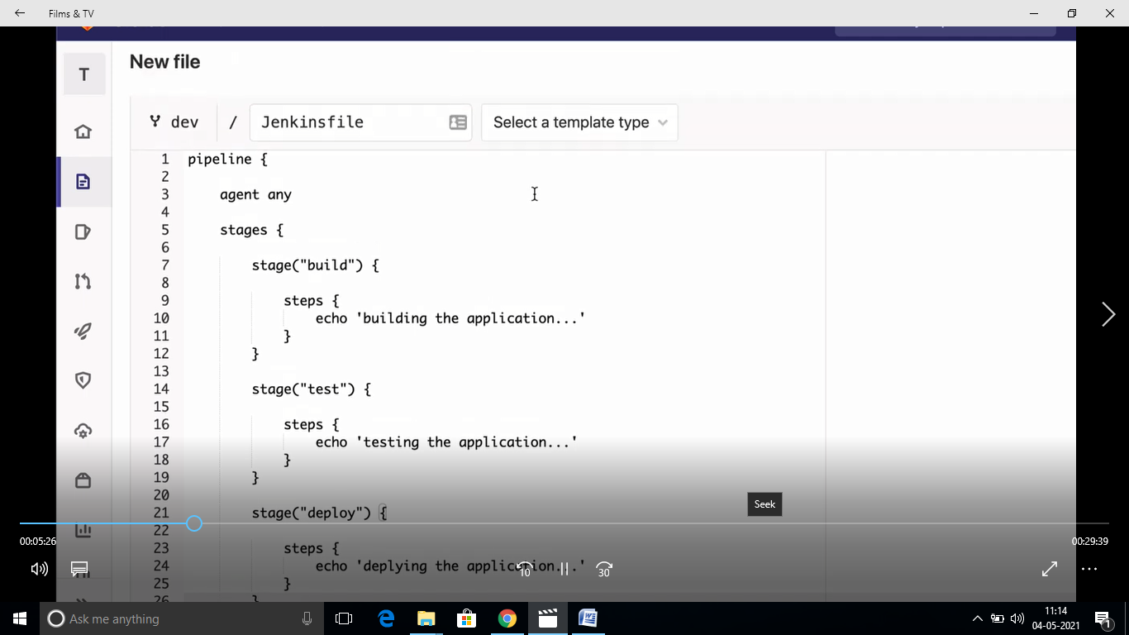

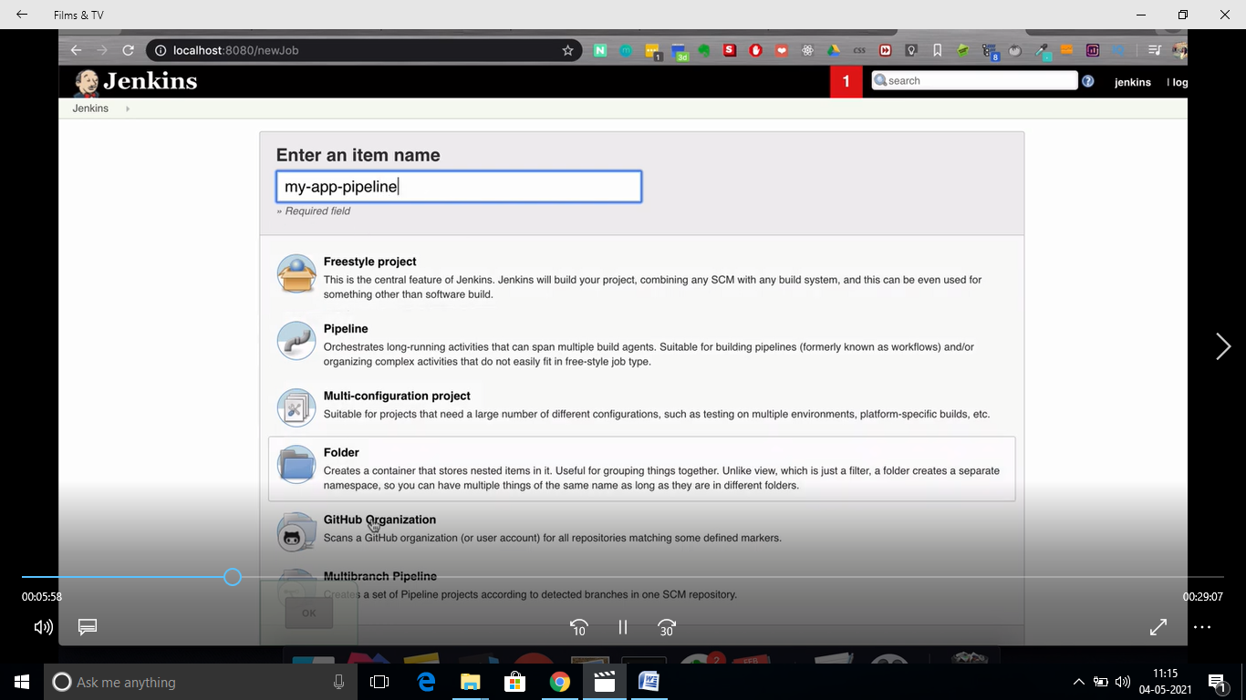

[**https://www.jenkins.io/doc/book/pipeline/**](https://www.jenkins.io/doc/book/pipeline/)

# Pipeline

[get started with Pipeline](https://www.jenkins.io/doc/book/pipeline/getting-started) - covers how to [define a Jenkins Pipeline](https://www.jenkins.io/doc/book/pipeline/getting-started#defining-a-pipeline) (i.e. your Pipeline) through [Blue Ocean](https://www.jenkins.io/doc/book/pipeline/getting-started#through-blue-ocean), through the [classic UI](https://www.jenkins.io/doc/book/pipeline/getting-started#through-the-classic-ui) or in [SCM](https://www.jenkins.io/doc/book/pipeline/getting-started#defining-a-pipeline-in-scm),

* [create and use a Jenkinsfile](https://www.jenkins.io/doc/book/pipeline/jenkinsfile) - covers use-case scenarios on how to craft and construct your Jenkinsfile,
* work with [branches and pull requests](https://www.jenkins.io/doc/book/pipeline/multibranch),
* [use Docker with Pipeline](https://www.jenkins.io/doc/book/pipeline/docker) - covers how Jenkins can invoke Docker containers on agents/nodes (from a Jenkinsfile) to build your Pipeline projects,
* [extend Pipeline with shared libraries](https://www.jenkins.io/doc/book/pipeline/shared-libraries),
* use different [development tools](https://www.jenkins.io/doc/book/pipeline/development) to facilitate the creation of your Pipeline, and
* work with [Pipeline syntax](https://www.jenkins.io/doc/book/pipeline/syntax) - this page is a comprehensive reference of all Declarative Pipeline syntax.

### Declarative versus Scripted Pipeline syntax

A Jenkinsfile can be written using two types of syntax - Declarative and Scripted.

Declarative and Scripted Pipelines are constructed fundamentally differently. Declarative Pipeline is a more recent feature of Jenkins Pipeline which:

* provides richer syntactical features over Scripted Pipeline syntax, and
* is designed to make writing and reading Pipeline code easier.

Many of the individual syntactical components (or "steps") written into a Jenkinsfile,

## Why Pipeline?

Jenkins is, fundamentally, an automation engine which supports a number of automation patterns. Pipeline adds a powerful set of automation tools onto Jenkins, supporting use cases that span from simple continuous integration to comprehensive CD pipelines. By modeling a series of related tasks, users can take advantage of the many features of Pipeline:

* **Code**: Pipelines are implemented in code and typically checked into source control, giving teams the ability to edit, review, and iterate upon their delivery pipeline.
* **Durable**: Pipelines can survive both planned and unplanned restarts of the Jenkins controller.
* **Pausable**: Pipelines can optionally stop and wait for human input or approval before continuing the Pipeline run.
* **Versatile**: Pipelines support complex real-world CD requirements, including the ability to fork/join, loop, and perform work in parallel.
* **Extensible**: The Pipeline plugin supports custom extensions to its DSL footnote:dsl:[] and multiple options for integration with other plugins.

While Jenkins has always allowed rudimentary forms of chaining Freestyle Jobs together to perform sequential tasks, [[4](https://www.jenkins.io/doc/book/pipeline/#_footnotedef_4)] Pipeline makes this concept a first-class citizen in Jenkins.

Building on the core Jenkins value of extensibility, Pipeline is also extensible both by users with [Pipeline Shared Libraries](https://www.jenkins.io/doc/book/pipeline/shared-libraries) and by plugin developers. [[5](https://www.jenkins.io/doc/book/pipeline/#_footnotedef_5)]

The flowchart below is an example of one CD scenario easily modeled in Jenkins Pipeline:

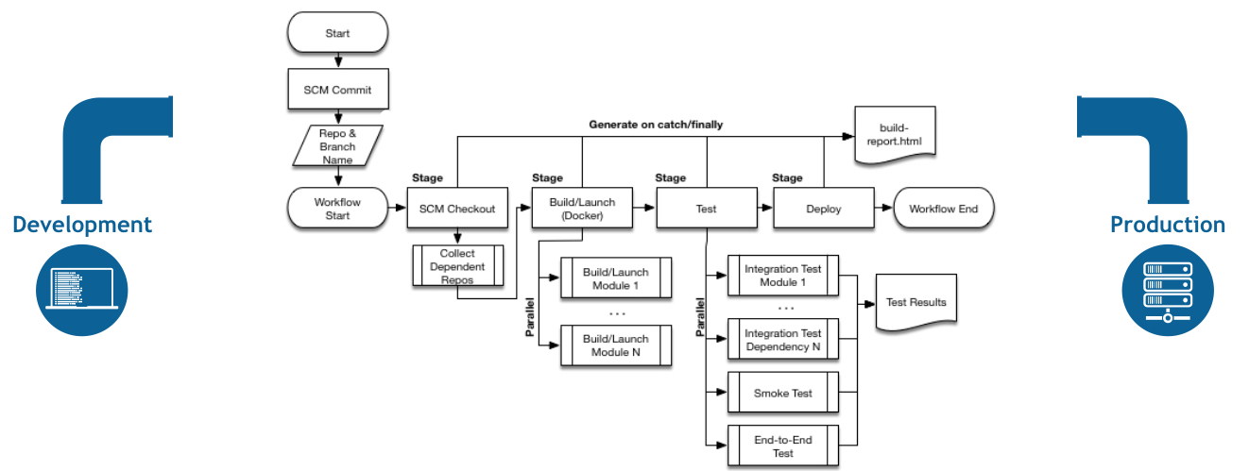

## Pipeline concepts

The following concepts are key aspects of Jenkins Pipeline, which tie in closely to Pipeline syntax (see the [overview](https://www.jenkins.io/doc/book/pipeline/#pipeline-syntax-overview) below).

### Pipeline

A Pipeline is a user-defined model of a CD pipeline. A Pipeline’s code defines your entire build process, which typically includes stages for building an application, testing it and then delivering it.

a pipeline block is a [key part of Declarative Pipeline syntax](https://www.jenkins.io/doc/book/pipeline/#declarative-pipeline-fundamentals).

### Node

A node is a machine which is part of the Jenkins environment and is capable of executing a Pipeline.

Also, a node block is a [key part of Scripted Pipeline syntax](https://www.jenkins.io/doc/book/pipeline/#scripted-pipeline-fundamentals).

### Stage

A stage block defines a conceptually distinct subset of tasks performed through the entire Pipeline (e.g. "Build", "Test" and "Deploy" stages), which is used by many plugins to visualize or present Jenkins Pipeline status/progress. [[6](https://www.jenkins.io/doc/book/pipeline/#_footnotedef_6)]

### Step

A single task. Fundamentally, a step tells Jenkins *what* to do at a particular point in time (or "step" in the process). For example, to execute the shell command make use the sh step: sh 'make'. When a plugin extends the Pipeline DSL, [[1](https://www.jenkins.io/doc/book/pipeline/#_footnotedef_1)] that typically means the plugin has implemented a new *step*.

## Pipeline syntax overview

[Declarative Pipeline syntax](https://www.jenkins.io/doc/book/pipeline/#declarative-pipeline-fundamentals) and [Scripted Pipeline syntax](https://www.jenkins.io/doc/book/pipeline/#scripted-pipeline-fundamentals).

Be aware that both [stages](https://www.jenkins.io/doc/book/pipeline/#stage) and [steps](https://www.jenkins.io/doc/book/pipeline/#step) (above) are common elements of both Declarative and Scripted Pipeline syntax.

### Declarative Pipeline fundamentals

In Declarative Pipeline syntax, the pipeline block defines all the work done throughout your entire Pipeline.

*Jenkinsfile (Declarative Pipeline)*

pipeline {

agent any

stages {

stage('Build') {

steps {

//

}

}

stage('Test') {

steps {

//

}

}

stage('Deploy') {

steps {

//

}

}

}

}

|  |  |
| --- | --- |
|  | Execute this Pipeline or any of its stages, on any available agent. |
|  | Defines the "Build" stage. |
|  | Perform some steps related to the "Build" stage. |
|  | Defines the "Test" stage. |
|  | Perform some steps related to the "Test" stage. |
|  | Defines the "Deploy" stage. |
|  | Perform some steps related to the "Deploy" stage. |

### Scripted Pipeline fundamentals

In Scripted Pipeline syntax, one or more node blocks do the core work throughout the entire Pipeline. Although this is not a mandatory requirement of Scripted Pipeline syntax, confining your Pipeline’s work inside of a node block does two things:

1. Schedules the steps contained within the block to run by adding an item to the Jenkins queue. As soon as an executor is free on a node, the steps will run.
2. Creates a workspace (a directory specific to that particular Pipeline) where work can be done on files checked out from source control.  
   **Caution:** Depending on your Jenkins configuration, some workspaces may not get automatically cleaned up after a period of inactivity. See tickets and discussion linked from [JENKINS-2111](https://issues.jenkins.io/browse/JENKINS-2111) for more information.

*Jenkinsfile (Scripted Pipeline)*

node {

stage('Build') {

//

}

stage('Test') {

//

}

stage('Deploy') {

//

}

}

|  |  |
| --- | --- |
|  | Execute this Pipeline or any of its stages, on any available agent. |
|  | Defines the "Build" stage. stage blocks are optional in Scripted Pipeline syntax. However, implementing stage blocks in a Scripted Pipeline provides clearer visualization of each `stage’s subset of tasks/steps in the Jenkins UI. |
|  | Perform some steps related to the "Build" stage. |
|  | Defines the "Test" stage. |
|  | Perform some steps related to the "Test" stage. |
|  | Defines the "Deploy" stage. |
|  | Perform some steps related to the "Deploy" stage. |

## Pipeline example

Here is an example of a Jenkinsfile using Declarative Pipeline syntax - its Scripted syntax equivalent can be accessed by clicking the **Toggle Scripted Pipeline** link below:

*Jenkinsfile (Declarative Pipeline)*

pipeline {

agent any

options {

skipStagesAfterUnstable()

}

stages {

stage('Build') {

steps {

sh 'make'

}

}

stage('Test'){

steps {

sh 'make check'

junit 'reports/**/*.xml'

}

}

stage('Deploy') {

steps {

sh 'make publish'

}

}

}

}

[Toggle Scripted Pipeline](https://www.jenkins.io/doc/book/pipeline/) *(Advanced)*

|  |  |
| --- | --- |
|  | [pipeline](https://www.jenkins.io/doc/book/pipeline/syntax#declarative-pipeline) is Declarative Pipeline-specific syntax that defines a "block" containing all content and instructions for executing the entire Pipeline. |
|  | [agent](https://www.jenkins.io/doc/book/pipeline/syntax#agent) is Declarative Pipeline-specific syntax that instructs Jenkins to allocate an executor (on a node) and workspace for the entire Pipeline. |
|  | stage is a syntax block that describes a [stage of this Pipeline](https://www.jenkins.io/doc/book/pipeline/#stage). Read more about stage blocks in Declarative Pipeline syntax on the [Pipeline syntax](https://www.jenkins.io/doc/book/pipeline/syntax#stage) page. As mentioned [above](https://www.jenkins.io/doc/book/pipeline/#scripted-pipeline-fundamentals), stage blocks are optional in Scripted Pipeline syntax. |
|  | [steps](https://www.jenkins.io/doc/book/pipeline/syntax#steps) is Declarative Pipeline-specific syntax that describes the steps to be run in this stage. |
|  | sh is a Pipeline [step](https://www.jenkins.io/doc/book/pipeline/syntax#steps) (provided by the [Pipeline: Nodes and Processes plugin](https://plugins.jenkins.io/workflow-durable-task-step)) that executes the given shell command. |
|  | junit is another a Pipeline [step](https://www.jenkins.io/doc/book/pipeline/syntax#steps) (provided by the [JUnit plugin](https://plugins.jenkins.io/junit)) for aggregating test reports. |
|  | node is Scripted Pipeline-specific syntax that instructs Jenkins to execute this Pipeline (and any stages contained within it), on any available agent/node. This is effectively equivalent to agent in Declarative Pipeline-specific syntax. |

In the [previous section](https://www.jenkins.io/doc/book/pipeline/jenkinsfile/) a Jenkinsfile which could be checked into source control was implemented. This section covers the concept of **Multibranch** Pipelines which build on the Jenkinsfile foundation to provide more dynamic and automatic functionality in Jenkins.

## Creating a Multibranch Pipeline

The **Multibranch Pipeline** project type enables you to implement different Jenkinsfiles for different branches of the same project. In a Multibranch Pipeline project, Jenkins automatically discovers, manages and executes Pipelines for branches which contain a Jenkinsfile in source control.

This eliminates the need for manual Pipeline creation and management.

To create a Multibranch Pipeline:

* Click **New Item** on Jenkins home page.

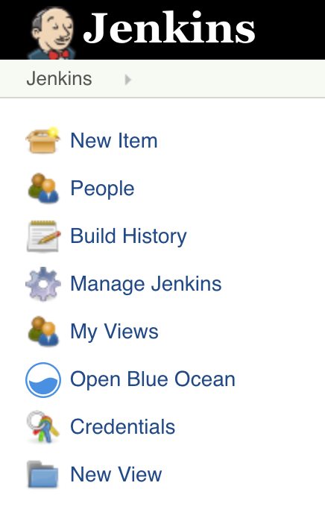

* Enter a name for your Pipeline, select **Multibranch Pipeline** and click **OK**.

|  |  |
| --- | --- |
|  | Jenkins uses the name of the Pipeline to create directories on disk. Pipeline names which include spaces may uncover bugs in scripts which do not expect paths to contain spaces. |

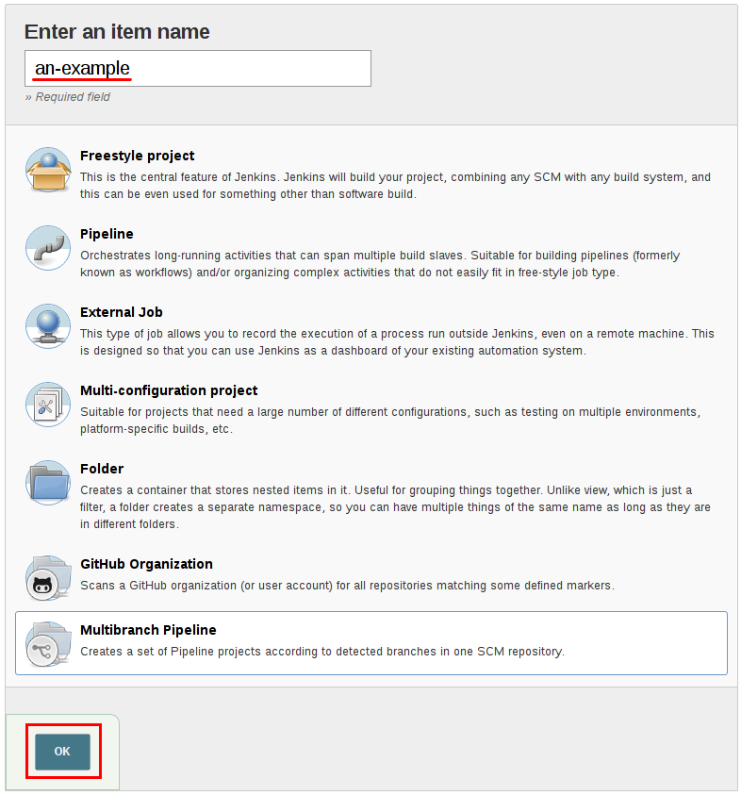

* Add a **Branch Source** (for example, Git) and enter the location of the repository.

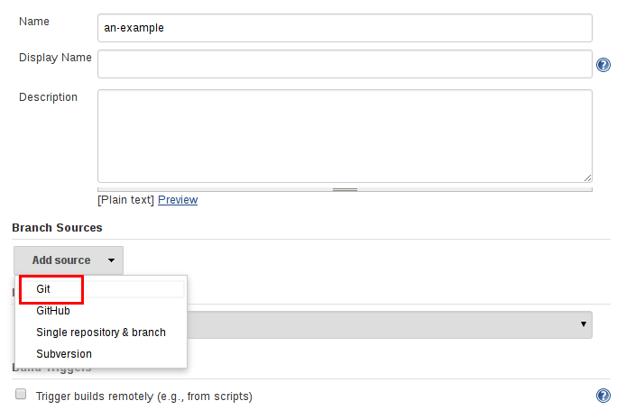

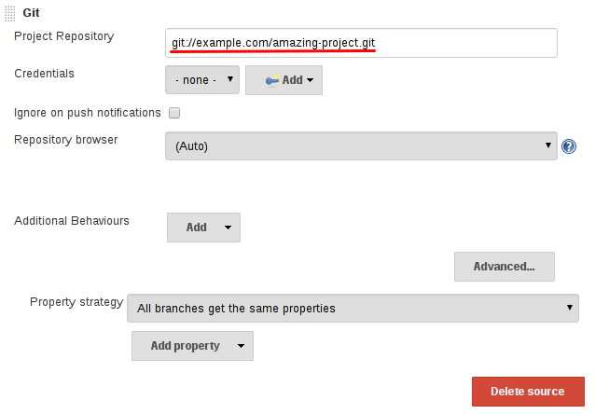

* **Save** the Multibranch Pipeline project.

Upon **Save**, Jenkins automatically scans the designated repository and creates appropriate items for each branch in the repository which contains a Jenkinsfile.

By default, Jenkins will not automatically re-index the repository for branch additions or deletions (unless using an [Organization Folder](https://www.jenkins.io/doc/book/pipeline/multibranch/#organization-folders)), so it is often useful to configure a Multibranch Pipeline to periodically re-index in the configuration:

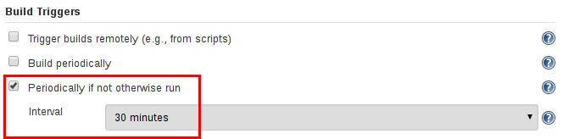

### Additional Environment Variables

Multibranch Pipelines expose additional information about the branch being built through the env global variable, such as:

**BRANCH_NAME**

Name of the branch for which this Pipeline is executing, for example master.

**CHANGE_ID**

An identifier corresponding to some kind of change request, such as a pull request number

Additional environment variables are listed in the [Global Variable Reference](https://www.jenkins.io/doc/book/pipeline/getting-started/#global-variable-reference#).

### Supporting Pull Requests

Multibranch Pipelines can be used for validating pull/change requests with the appropriate plugin. This functionality is provided by the following plugins:

* [GitHub Branch Source](https://plugins.jenkins.io/github-branch-source)
* [Bitbucket Branch Source](https://plugins.jenkins.io/cloudbees-bitbucket-branch-source)
* [GitLab Branch Source](https://plugins.jenkins.io/gitlab-branch-source)
* [Gitea](https://plugins.jenkins.io/gitea)
* [Tuleap Git Branch Source](https://plugins.jenkins.io/tuleap-git-branch-source)
* [AWS CodeCommit Jobs](https://plugins.jenkins.io/aws-codecommit-jobs)
* [DAGsHub Branch Source](https://plugins.jenkins.io/dagshub-branch-source)

Please consult their documentation for further information on how to use those plugins.

## Using Organization Folders

Organization Folders enable Jenkins to monitor an entire GitHub Organization, Bitbucket Team/Project, GitLab organization, or Gitea organization and automatically create new Multibranch Pipelines for repositories which contain branches and pull requests containing a Jenkinsfile.

Organization folders are implemented for:

* GitHub in the [GitHub Organization Folder](https://plugins.jenkins.io/github-organization-folder) plugin
* Bitbucket in the [Bitbucket Branch Source](https://plugins.jenkins.io/cloudbees-bitbucket-branch-source) plugin
* GitLab in the [GitLab Branch Source](https://plugins.jenkins.io/gitlab-branch-source) plugin
* Gitea in the [Gitea](https://plugins.jenkins.io/gitea) plugin

# Pipeline Development Tools

Jenkins Pipeline includes [built-in documentation](https://www.jenkins.io/doc/book/pipeline/getting-started/#built-in-documentation) and the [Snippet Generator](https://www.jenkins.io/doc/book/pipeline/getting-started/#snippet-generator) which are key resources when developing Pipelines. They provide detailed help and information that is customized to the currently installed version of Jenkins and related plugins. In this section, we’ll discuss other tools and resources that may help with development of Jenkins Pipelines.

## Blue Ocean Editor

The [Blue Ocean Pipeline Editor](https://www.jenkins.io/doc/book/blueocean/pipeline-editor/) provides a [WYSIWYG](https://en.wikipedia.org/wiki/WYSIWYG) way to create Declarative Pipelines. The editor offers a structural view of all the stages, parallel branches, and steps in a Pipeline. The editor validates Pipeline changes as they are made, eliminating many errors before they are even committed. Behind the scenes it still generates Declarative Pipeline code.

## Command-line Pipeline Linter

Jenkins can validate, or "[lint](https://en.wikipedia.org/wiki/Lint_(software))", a Declarative Pipeline from the command line before actually running it. This can be done using a Jenkins CLI command or by making an HTTP POST request with appropriate parameters. We recommended using the [SSH interface](https://www.jenkins.io/doc/book/managing/cli/#ssh) to run the linter. See the [Jenkins CLI documentation](https://www.jenkins.io/doc/book/managing/cli/) for details on how to properly configure Jenkins for secure command-line access.

*Linting via the CLI with SSH*

# ssh (Jenkins CLI)

# JENKINS_SSHD_PORT=[sshd port on controller]

# JENKINS_HOSTNAME=[Jenkins controller hostname]

ssh -p $JENKINS_SSHD_PORT $JENKINS_HOSTNAME declarative-linter < Jenkinsfile

*Linting via HTTP POST using curl*

# curl (REST API)

# Assuming "anonymous read access" has been enabled on your Jenkins instance.

# JENKINS_URL=[root URL of Jenkins controller]

# JENKINS_CRUMB is needed if your Jenkins controller has CRSF protection enabled as it should

JENKINS_CRUMB=`curl "$JENKINS_URL/crumbIssuer/api/xml?xpath=concat(//crumbRequestField,\":\",//crumb)"`

curl -X POST -H $JENKINS_CRUMB -F "jenkinsfile=<Jenkinsfile" $JENKINS_URL/pipeline-model-converter/validate

### Examples

Below are two examples of the Pipeline Linter in action. This first example shows the output of the linter when it is passed an invalid Jenkinsfile, one that is missing part of the agent declaration.

*Jenkinsfile*

pipeline {

agent

stages {

stage ('Initialize') {

steps {

echo 'Placeholder.'

}

}

}

}

*Linter output for invalid Jenkinsfile*

# pass a Jenkinsfile that does not contain an "agent" section

ssh -p 8675 localhost declarative-linter < ./Jenkinsfile

Errors encountered validating Jenkinsfile:

WorkflowScript: 2: Not a valid section definition: "agent". Some extra configuration is required. @ line 2, column 3.

agent

^

WorkflowScript: 1: Missing required section "agent" @ line 1, column 1.

pipeline &#125;

^

In this second example, the Jenkinsfile has been updated to include the missing any on agent. The linter now reports that the Pipeline is valid.

*Jenkinsfile*

pipeline {

agent any

stages {

stage ('Initialize') {

steps {

echo 'Placeholder.'

}

}

}

}

*Linter output for valid Jenkinsfile*

ssh -p 8675 localhost declarative-linter < ./Jenkinsfile

Jenkinsfile successfully validated.

## "Replay" Pipeline Runs with Modifications

Typically a Pipeline will be defined inside of the classic Jenkins web UI, or by committing to a Jenkinsfile in source control. Unfortunately, neither approach is ideal for rapid iteration, or prototyping, of a Pipeline. The "Replay" feature allows for quick modifications and execution of an existing Pipeline without changing the Pipeline configuration or creating a new commit.

### Usage

To use the "Replay" feature:

1. Select a previously completed run in the build history.

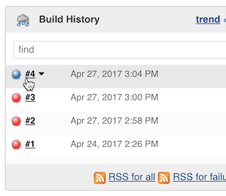

1. Click "Replay" in the left menu

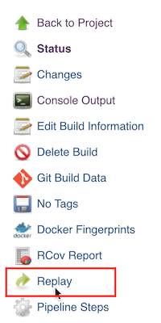

1. Make modifications and click "Run". In this example, we changed "ruby-2.3" to "ruby-2.4".

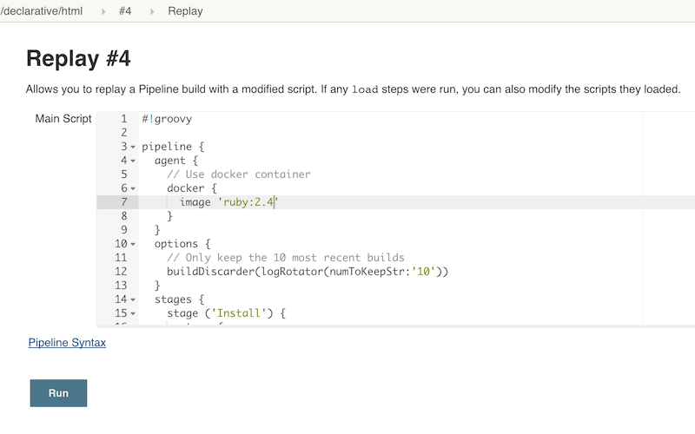

1. Check the results of changes

Once you are satisfied with the changes, you can use Replay to view them again, copy them back to your Pipeline job or Jenkinsfile, and then commit them using your usual engineering processes.

### Features

* **Can be called multiple times on the same run** - allows for easy parallel testing of different changes.
* **Can also be called on Pipeline runs that are still in-progress** - As long as a Pipeline contained syntactically correct Groovy and was able to start, it can be Replayed.
* **Referenced Shared Library code is also modifiable** - If a Pipeline run references a [Shared Library](https://www.jenkins.io/doc/book/pipeline/shared-libraries/), the code from the shared library will also be shown and modifiable as part of the Replay page.

### Limitations

* **Pipeline runs with syntax errors cannot be replayed** - meaning their code cannot be viewed and any changes made in them cannot be retrieved. When using Replay for more significant modifications, save your changes to a file or editor outside of Jenkins before running them. See [JENKINS-37589](https://issues.jenkins.io/browse/JENKINS-37589)
* **Replayed Pipeline behavior may differ from runs started by other methods** - For Pipelines that are not part of a Multi-branch Pipeline, the commit information may differ for the original run and the Replayed run. See [JENKINS-36453](https://issues.jenkins.io/browse/JENKINS-36453)

## IDE Integrations

### Eclipse Jenkins Editor

The Jenkins Editor Eclipse plugin can be found on [Eclipse Marketplace](https://marketplace.eclipse.org/content/jenkins-editor). This special text editor provides some features for defining pipelines e.g:

* Validate pipeline scripts by [Jenkins Linter Validation](https://www.jenkins.io/doc/book/pipeline/development/#linter). Failures are shown as eclipse markers
* An Outline with dedicated icons (for declarative Jenkins pipelines )
* Syntax / keyword highlighting
* Groovy validation

|  |  |
| --- | --- |
|  | The Jenkins Editor Plugin is a third-party tool that is not supported by the Jenkins Project. |

### VisualStudio Code Jenkins Pipeline Linter Connector

The Jenkins Pipeline Linter Connector extension for [VisualStudio Code](https://code.visualstudio.com/) takes the file that you have currently opened, pushes it to your Jenkins Server and displays the validation result in VS Code.

​You can find the extension from within the VS Code extension browser or at the following url: [marketplace.visualstudio.com/items?itemName=janjoerke.jenkins-pipeline-linter-connector](https://marketplace.visualstudio.com/items?itemName=janjoerke.jenkins-pipeline-linter-connector)

The extension adds four settings entries to VS Code which select the Jenkins server you want to use for validation.

* jenkins.pipeline.linter.connector.url is the endpoint at which your Jenkins Server expects the POST request, containing your Jenkinsfile which you want to validate. Typically this points to *<your_jenkins_server:port>/pipeline-model-converter/validate*.
* jenkins.pipeline.linter.connector.user allows you to specify your Jenkins username.
* jenkins.pipeline.linter.connector.pass allows you to specify your Jenkins password.
* jenkins.pipeline.linter.connector.crumbUrl has to be specified if your Jenkins Server has CRSF protection enabled. Typically this points to *<your_jenkins_server:port>/crumbIssuer/api/xml?xpath=concat(//crumbRequestField,%22:%22,//crumb)*.

### Atom linter-jenkins package

The [linter-jenkins](https://atom.io/packages/linter-jenkins) Atom package allows you to validate a Jenkins file by using the Pipeline Linter API of a running Jenkins. You can install it directly from the Atom package manager. It needs also to install [Jenkinsfile language support in Atom](https://atom.io/packages/language-jenkinsfile)

### Sublime Text Jenkinsfile package

The [Jenkinsfile](https://github.com/june07/sublime-Jenkinsfile) Sublime Text package allows you to validate a Jenkinsfile by using the Pipeline Linter API of a running Jenkins instance over a secure channel (SSH). You can install it directly from the Sublime Text package manager.

​You can find the package from within the Sublime Text interface via the Package Control package, at GitHub, or packagecontrol.io:

* <https://github.com/june07/sublime-Jenkinsfile>
* <https://packagecontrol.io/packages/Jenkinsfile>

## Pipeline Unit Testing Framework

The [Pipeline Unit Testing Framework](https://github.com/jenkinsci/JenkinsPipelineUnit) allows you to [unit test](https://en.wikipedia.org/wiki/Unit_testing) Pipelines and [Shared Libraries](https://www.jenkins.io/doc/book/pipeline/shared-libraries/) before running them in full. It provides a mock execution environment where real Pipeline steps are replaced with mock objects that you can use to check for expected behavior. New and rough around the edges, but promising. The [README](https://github.com/jenkinsci/JenkinsPipelineUnit/blob/master/README.md) for that project contains examples and usage instructions.

## Declarative Pipeline

Declarative Pipeline is a relatively recent addition to Jenkins Pipeline [[1](https://www.jenkins.io/doc/book/pipeline/syntax/#_footnotedef_1)] which presents a more simplified and opinionated syntax on top of the Pipeline sub-systems.

All valid Declarative Pipelines must be enclosed within a pipeline block, for example:

pipeline {

/* insert Declarative Pipeline here */

}

The basic statements and expressions which are valid in Declarative Pipeline follow the same rules as [Groovy’s syntax](http://groovy-lang.org/syntax.html) with the following exceptions:

* The top-level of the Pipeline must be a *block*, specifically: pipeline { }.
* No semicolons as statement separators. Each statement has to be on its own line.
* Blocks must only consist of [Sections](https://www.jenkins.io/doc/book/pipeline/syntax/#declarative-sections), [Directives](https://www.jenkins.io/doc/book/pipeline/syntax/#declarative-directives), [Steps](https://www.jenkins.io/doc/book/pipeline/syntax/#declarative-steps), or assignment statements.
* A property reference statement is treated as a no-argument method invocation. So, for example, input is treated as input().

You can use the [Declarative Directive Generator](https://www.jenkins.io/doc/book/pipeline/getting-started/#directive-generator) to help you get started with configuring the directives and sections in your Declarative Pipeline.

### Limitations

There is currently an [open issue](https://issues.jenkins.io/browse/JENKINS-37984) which limits the maximum size of the code within the pipeline{} block. This limitation does not apply to Scripted pipelines.

### Sections

Sections in Declarative Pipeline typically contain one or more [Directives](https://www.jenkins.io/doc/book/pipeline/syntax/#declarative-directives) or [Steps](https://www.jenkins.io/doc/book/pipeline/syntax/#declarative-steps).

#### agent

The agent section specifies where the entire Pipeline, or a specific stage, will execute in the Jenkins environment depending on where the agent section is placed. The section must be defined at the top-level inside the pipeline block, but stage-level usage is optional.

|  |  |
| --- | --- |
| **Required** | Yes |
| **Parameters** | [Described below](https://www.jenkins.io/doc/book/pipeline/syntax/#agent-parameters) |
| **Allowed** | In the top-level pipeline block and each stage block. |

##### **Differences between top and stage level Agents**

There are some nuances when adding an agent to the top level or a stage level, and this when the options directive is applied.

###### **Top Level Agents**

In agents declared at the outermost level of the Pipeline, the options are invoked **after** entering the agent. As an example, when using timeout it will be only applied to the execution **within** the agent.

node("myAgent") {

timeout(unit: 'SECONDS', time: 5) {

stage("One"){

sleep 10

echo 'hello'

}

}

}

###### **Stage Agents**

In agents declared within a stage, the options are invoked **before** entering the agent and **before** checking any when conditions. In this case, when using timeout, it is applied **before** the agent is allocated.

timeout(unit: 'SECONDS', time: 5) {

stage("One"){

node {

sleep 10

echo 'Hello'

}

}

}

This timeout will include the agent provisioning time. Because the timeout includes the agent provisioning time, the Pipeline may fail in cases where agent allocation is delayed.

##### **Parameters**

In order to support the wide variety of use-cases Pipeline authors may have, the agent section supports a few different types of parameters. These parameters can be applied at the top-level of the pipeline block, or within each stage directive.

**any**

Execute the Pipeline, or stage, on any available agent. For example: agent any

**none**

When applied at the top-level of the pipeline block no global agent will be allocated for the entire Pipeline run and each stage section will need to contain its own agent section. For example: agent none

**label**

Execute the Pipeline, or stage, on an agent available in the Jenkins environment with the provided label. For example: agent { label 'my-defined-label' }

Label conditions can also be used. For example: agent { label 'my-label1 && my-label2' } or agent { label 'my-label1 || my-label2' }

**node**

agent { node { label 'labelName' } } behaves the same as agent { label 'labelName' }, but node allows for additional options (such as customWorkspace).

**docker**

Execute the Pipeline, or stage, with the given container which will be dynamically provisioned on a [node](https://www.jenkins.io/doc/book/glossary/#node) pre-configured to accept Docker-based Pipelines, or on a node matching the optionally defined label parameter. docker also optionally accepts an args parameter which may contain arguments to pass directly to a docker run invocation, and an alwaysPull option, which will force a docker pull even if the image name is already present. For example: agent { docker 'maven:3.8.1-adoptopenjdk-11' } or

agent {

docker {

image 'maven:3.8.1-adoptopenjdk-11'

label 'my-defined-label'

args '-v /tmp:/tmp'

}

}

docker also optionally accepts a registryUrl and registryCredentialsId parameters which will help to specify the Docker Registry to use and its credentials. The parameter registryCredentialsId could be used alone for private repositories within the docker hub. For example:

agent {

docker {

image 'myregistry.com/node'

label 'my-defined-label'

registryUrl 'https://myregistry.com/'

registryCredentialsId 'myPredefinedCredentialsInJenkins'

}

}

**dockerfile**

Execute the Pipeline, or stage, with a container built from a Dockerfile contained in the source repository. In order to use this option, the Jenkinsfile must be loaded from either a **Multibranch Pipeline** or a **Pipeline from SCM**. Conventionally this is the Dockerfile in the root of the source repository: agent { dockerfile true }.

**kubernetes**

Execute the Pipeline, or stage, inside a pod deployed on a Kubernetes cluster. In order to use this option, the Jenkinsfile must be loaded from either a **Multibranch Pipeline** or a **Pipeline from SCM**. The Pod template is defined inside the kubernetes { } block. For example, if you want a pod with a Kaniko container inside it, you would define it as follows:

agent {

kubernetes {

label podlabel

yaml """

kind: Pod

metadata:

name: jenkins-agent

spec:

containers:

- name: kaniko

image: gcr.io/kaniko-project/executor:debug

imagePullPolicy: Always

command:

- /busybox/cat

tty: true

volumeMounts:

- name: aws-secret

mountPath: /root/.aws/

- name: docker-registry-config

mountPath: /kaniko/.docker

restartPolicy: Never

volumes:

- name: aws-secret

secret:

secretName: aws-secret

- name: docker-registry-config

configMap:

name: docker-registry-config

"""

}

You will need to create a secret aws-secret for Kaniko to be able to authenticate with ECR. This secret should contain the contents of ~/.aws/credentials. The other volume is a ConfigMap which should contain the endpoint of your ECR registry. For example:

{

"credHelpers": {

"<your-aws-account-id>.dkr.ecr.eu-central-1.amazonaws.com": "ecr-login"

}

}

Refer to the following example for reference: <https://github.com/jenkinsci/kubernetes-plugin/blob/master/examples/kaniko.groovy>

##### **Common Options**

These are a few options that can be applied to two or more agent implementations. They are not required unless explicitly stated.

**label**

A string. The label or label condition on which to run the Pipeline or individual stage.

This option is valid for node, docker, and dockerfile, and is required for node.

**customWorkspace**

A string. Run the Pipeline or individual stage this agent is applied to within this custom workspace, rather than the default. It can be either a relative path, in which case the custom workspace will be under the workspace root on the node, or an absolute path. For example:

agent {

node {

label 'my-defined-label'

customWorkspace '/some/other/path'

}

}

This option is valid for node, docker, and dockerfile.

**reuseNode**

A boolean, false by default. If true, run the container on the node specified at the top-level of the Pipeline, in the same workspace, rather than on a new node entirely.

This option is valid for docker and dockerfile, and only has an effect when used on an agent for an individual stage.

**args**

A string. Runtime arguments to pass to docker run.

This option is valid for docker and dockerfile.

*Example 1. Docker Agent, Declarative Pipeline*

pipeline {

agent { docker 'maven:3.8.1-adoptopenjdk-11' }

stages {

stage('Example Build') {

steps {

sh 'mvn -B clean verify'

}

}

}

}

|  |  |
| --- | --- |
|  | Execute all the steps defined in this Pipeline within a newly created container of the given name and tag (3.8.1-adoptopenjdk-11). |

*Example 2. Stage-level Agent Section*

pipeline {

agent none

stages {

stage('Example Build') {

agent { docker 'maven:3.8.1-adoptopenjdk-11' }

steps {

echo 'Hello, Maven'

sh 'mvn --version'

}

}

stage('Example Test') {

agent { docker 'openjdk:8-jre' }

steps {

echo 'Hello, JDK'

sh 'java -version'

}

}

}

}

|  |  |
| --- | --- |
|  | Defining agent none at the top-level of the Pipeline ensures that [an Executor](https://www.jenkins.io/doc/book/glossary/#executor) will not be assigned unnecessarily. Using agent none also forces each stage section to contain its own agent section. |
|  | Execute the steps in this stage in a newly created container using this image. |
|  | Execute the steps in this stage in a newly created container using a different image from the previous stage. |

##### **Conditions**

**always**

Run the steps in the post section regardless of the completion status of the Pipeline’s or stage’s run.

**changed**

Only run the steps in post if the current Pipeline’s or stage’s run has a different completion status from its previous run.

**fixed**

Only run the steps in post if the current Pipeline’s or stage’s run is successful and the previous run failed or was unstable.

**regression**

Only run the steps in post if the current Pipeline’s or stage’s run’s status is failure, unstable, or aborted and the previous run was successful.

**aborted**

Only run the steps in post if the current Pipeline’s or stage’s run has an "aborted" status, usually due to the Pipeline being manually aborted. This is typically denoted by gray in the web UI.

**failure**

Only run the steps in post if the current Pipeline’s or stage’s run has a "failed" status, typically denoted by red in the web UI.

**success**

Only run the steps in post if the current Pipeline’s or stage’s run has a "success" status, typically denoted by blue or green in the web UI.

**unstable**

Only run the steps in post if the current Pipeline’s or stage’s run has an "unstable" status, usually caused by test failures, code violations, etc. This is typically denoted by yellow in the web UI.

**unsuccessful**

Only run the steps in post if the current Pipeline’s or stage’s run has not a "success" status. This is typically denoted in the web UI depending on the status previously mentioned.

**cleanup**

Run the steps in this post condition after every other post condition has been evaluated, regardless of the Pipeline or stage’s status.

*Example 3. Post Section, Declarative Pipeline*

pipeline {

agent any

stages {

stage('Example') {

steps {

echo 'Hello World'

}

}

}

post {

always {

echo 'I will always say Hello again!'

}

}

}

|  |  |
| --- | --- |
|  | Conventionally, the post section should be placed at the end of the Pipeline. |
|  | [Post-condition](https://www.jenkins.io/doc/book/pipeline/syntax/#post-conditions) blocks contain [steps](https://www.jenkins.io/doc/book/pipeline/syntax/#declarative-steps) the same as the [steps](https://www.jenkins.io/doc/book/pipeline/syntax/#steps) section. |

#### stages

Containing a sequence of one or more [stage](https://www.jenkins.io/doc/book/pipeline/syntax/#stage) directives, the stages section is where the bulk of the "work" described by a Pipeline will be located. At a minimum, it is recommended that stages contain at least one [stage](https://www.jenkins.io/doc/book/pipeline/syntax/#stage) directive for each discrete part of the continuous delivery process, such as Build, Test, and Deploy.

|  |  |
| --- | --- |
| **Required** | Yes |
| **Parameters** | *None* |
| **Allowed** | Only once, inside the pipeline block. |

*Example 4. Stages, Declarative Pipeline*

pipeline {

agent any

stages {

stage('Example') {

steps {

echo 'Hello World'

}

}

}

}

|  |  |
| --- | --- |
|  | The stages section will typically follow the directives such as agent, options, etc. |

#### steps

The steps section defines a series of one or more [steps](https://www.jenkins.io/doc/book/pipeline/syntax/#declarative-steps) to be executed in a given stage directive.

|  |  |
| --- | --- |
| **Required** | Yes |
| **Parameters** | *None* |
| **Allowed** | Inside each stage block. |

*Example 5. Single Step, Declarative Pipeline*

pipeline {

agent any

stages {

stage('Example') {

steps {

echo 'Hello World'

}

}

}

}

|  |  |
| --- | --- |
|  | The steps section must contain one or more steps. |

### Directives

#### environment

The environment directive specifies a sequence of key-value pairs which will be defined as environment variables for all steps, or stage-specific steps, depending on where the environment directive is located within the Pipeline.

This directive supports a special helper method credentials() which can be used to access pre-defined Credentials by their identifier in the Jenkins environment.

|  |  |
| --- | --- |
| **Required** | No |
| **Parameters** | *None* |
| **Allowed** | Inside the pipeline block, or within stage directives. |

##### **Supported Credentials Type**

**Secret Text**

the environment variable specified will be set to the Secret Text content

**Secret File**

the environment variable specified will be set to the location of the File file that is temporarily created

**Username and password**

the environment variable specified will be set to username:password and two additional environment variables will be automatically defined: MYVARNAME_USR and MYVARNAME_PSW respectively.

**SSH with Private Key**

the environment variable specified will be set to the location of the SSH key file that is temporarily created and two additional environment variables may be automatically defined: MYVARNAME_USR and MYVARNAME_PSW (holding the passphrase).

|  |  |
| --- | --- |
|  |  |

*Example 6. Secret Text Credentials, Declarative Pipeline*

pipeline {

agent any

environment {

CC = 'clang'

}

stages {

stage('Example') {

environment {

AN_ACCESS_KEY = credentials('my-predefined-secret-text')

}

steps {

sh 'printenv'

}

}

}

}

|  |  |
| --- | --- |
|  | An environment directive used in the top-level pipeline block will apply to all steps within the Pipeline. |
|  | An environment directive defined within a stage will only apply the given environment variables to steps within the stage. |
|  | The environment block has a helper method credentials() defined which can be used to access pre-defined Credentials by their identifier in the Jenkins environment. |

*Example 7. Username and Password Credentials*

pipeline {

agent any

stages {

stage('Example Username/Password') {

environment {

SERVICE_CREDS = credentials('my-predefined-username-password')

}

steps {

sh 'echo "Service user is $SERVICE_CREDS_USR"'

sh 'echo "Service password is $SERVICE_CREDS_PSW"'

sh 'curl -u $SERVICE_CREDS https://myservice.example.com'

}

}

stage('Example SSH Username with private key') {

environment {

SSH_CREDS = credentials('my-predefined-ssh-creds')

}

steps {

sh 'echo "SSH private key is located at $SSH_CREDS"'

sh 'echo "SSH user is $SSH_CREDS_USR"'

sh 'echo "SSH passphrase is $SSH_CREDS_PSW"'

}

}

}

}

#### options

The options directive allows configuring Pipeline-specific options from within the Pipeline itself. Pipeline provides a number of these options, such as buildDiscarder, but they may also be provided by plugins, such as timestamps.

|  |  |
| --- | --- |
| **Required** | No |
| **Parameters** | *None* |
| **Allowed** | Only once, inside the pipeline block. |

##### **Available Options**

**buildDiscarder**

Persist artifacts and console output for the specific number of recent Pipeline runs. For example: options { buildDiscarder(logRotator(numToKeepStr: '1')) }

**disableConcurrentBuilds**

Disallow concurrent executions of the Pipeline. Can be useful for preventing simultaneous accesses to shared resources, etc. For example: options { disableConcurrentBuilds() }

**disableResume**

Do not allow the pipeline to resume if the controller restarts. For example: options { disableResume() }

**newContainerPerStage**

Used with docker or dockerfile top-level agent. When specified, each stage will run in a new container instance on the same node, rather than all stages running in the same container instance.

**overrideIndexTriggers**

Allows overriding default treatment of branch indexing triggers. If branch indexing triggers are disabled at the multibranch or organization label, options { overrideIndexTriggers(true) } will enable them for this job only. Otherwise, options { overrideIndexTriggers(false) } will disable branch indexing triggers for this job only.

**preserveStashes**

Preserve stashes from completed builds, for use with stage restarting. For example: options { preserveStashes() } to preserve the stashes from the most recent completed build, or options { preserveStashes(buildCount: 5) } to preserve the stashes from the five most recent completed builds.

**uietPeriod**

Set the quiet period, in seconds, for the Pipeline, overriding the global default. For example: options { quietPeriod(30) }

**retry**

On failure, retry the entire Pipeline the specified number of times. For example: options { retry(3) }

**skipDefaultCheckout**

Skip checking out code from source control by default in the agent directive. For example: options { skipDefaultCheckout() }

**skipStagesAfterUnstable**

Skip stages once the build status has gone to UNSTABLE. For example: options { skipStagesAfterUnstable() }

**timeout**

Set a timeout period for the Pipeline run, after which Jenkins should abort the Pipeline. For example: options { timeout(time: 1, unit: 'HOURS') }

*Example 8. Global Timeout, Declarative Pipeline*

pipeline {

agent any

options {

timeout(time: 1, unit: 'HOURS')

}

stages {

stage('Example') {

steps {

echo 'Hello World'

}

}

}

}

|  |  |
| --- | --- |
|  | Specifying a global execution timeout of one hour, after which Jenkins will abort the Pipeline run. |

**timestamps**

Prepend all console output generated by the Pipeline run with the time at which the line was emitted. For example: options { timestamps() }

**parallelsAlwaysFailFast**

Set failfast true for all subsequent parallel stages in the pipeline. For example: options { parallelsAlwaysFailFast() }

|  |  |
| --- | --- |
|  | A comprehensive list of available options is pending the completion of [INFRA-1503](https://issues.jenkins.io/browse/INFRA-1053). |

**skipDefaultCheckout**

Skip checking out code from source control by default in the agent directive. For example: options { skipDefaultCheckout() }

**timeout**

Set a timeout period for this stage, after which Jenkins should abort the stage. For example: options { timeout(time: 1, unit: 'HOURS') }

*Example 9. Stage Timeout, Declarative Pipeline*

pipeline {

agent any

stages {

stage('Example') {

options {

timeout(time: 1, unit: 'HOURS')

}

steps {

echo 'Hello World'

}

}

}

}